Report
Conservation Awareness Programs in Pipar Pheasant Conservation Landscape
(Strengthening Conservation Knowledge)
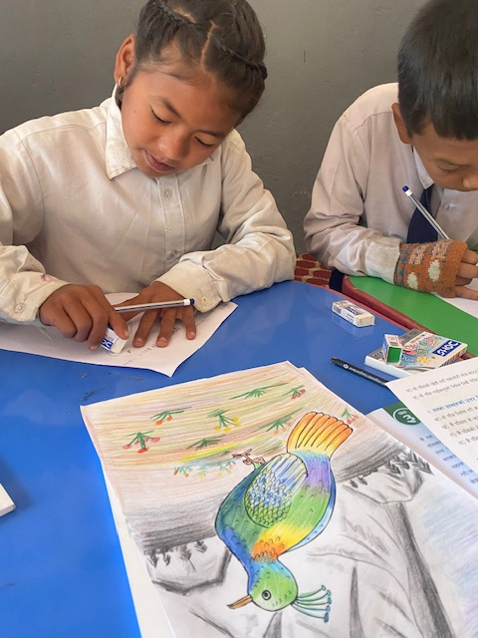
Submitted by:
Biodiversity Conservation Society Nepal (BIOCOS Nepal)

Submitted to:
World Pheasant Association (WPA)

July 2025

Table of Content

Summary iv
Acronyms v
1. Introduction 1
1.1. Background 1
1.2. Objectives 2
1.2.1. General Objective 2
1.2.2. Specific Objectives 2
2. Program Site 3
2.1. Pipar Pheasant Conservation Landscape 3
3. Program Implementation 5
3.1. Teacher Training on Conservation Education 5
3.2. School Visit 5
3.3. Drawing Competition 5
3.4. Installation of Awareness Boards 5
3.5. Art Program: Pheasant Wall Art in Schools 6
3.6. Environmental Awareness Day Out 6
3.7. Interaction with local communities 6
3.8. Press release on Pheasant survey 7
4. Result and Discussion 8
4.1. Teacher Training on Conservation Education 8
4.2. School Visit 12
4.3. Drawing Competition 13
4.4. Installation of Awareness Boards 15
4.5. Art Program: Pheasant Wall Art in Schools 15
4.6. Environmental Awareness Day Out 17
4.7. Interaction with local communities 18
4.8. Press release on Pheasant survey 18
5. Key outputs and achievements of conservation education program 21
6. Conclusion and Recommendation 23
6.1. Conclusion 23
6.2. Recommendation 23
Annex 25
Annex1: Program schedule of teacher’s training held in February 2025. 25
Annex 2: Bird Checklist prepared by teachers during field visit during the training 26
Annex 3: list of news articles 27

Acknowledgement
We would like to sincerely thank the World Pheasant Association (WPA) for their generous financial support, and the BIOCOS team for their valuable guidance throughout the implementation of this project. Their contributions have been instrumental in turning our vision into reality. We also thank Lancashire for their support.
We’d like to thank everyone who contributed to the successful implementation of our awareness program in the Pipar Pheasants Conservation Landscape. Their involvement made possible a range of meaningful activities, including wall art sessions, excursions, teacher training, hand-drawing competitions, prize distributions, and the installation of awareness boards. These efforts would not have been as impactful without their support, knowledge, and experience.
We would like to express our profound gratitude to all individuals who attended the press meet, without them sharing the issues of PPCL to a wider audience would not have been possible. A special thanks to the WPA-supported schools, local artists, and representatives from the local administrative units, Annapurna Conservation Area Project, Conservation Area Management Committee, and Great Machhapuchre Trail Committee. We extend our appreciation to the 5th grade students from all WPA schools for their enthusiastic participation. Their commitment to conservation and education made this project possible.

Summary
The expanded Pipar Pheasant Conservation Landscape (PPCL) now stretches from the Seti River in the east to the Mardi River in the west, encompassing areas such as Khumai, Korchon, Karuwa, Ghachowk, and Lwang-Ghalel. Within this landscape, a Conservation Awareness Program has been implemented, with conservation education in local communities as a key strategy.
WPA and BIOCOS introduced Junior Conservation Knowledge (JCK)—a conservation-focused book by Christine Stone—into the curriculum of 12 local schools through dedicated teacher training. Each school received 10 copies of books to be used as a reference resource. A teacher training workshop was held in February 2025, equipping 13 teachers from 11 schools with the tools to educate students about biodiversity and pheasant conservation.
To further promote youth engagement, the program included school visits, drawing competitions, and wall art projects. Wall murals created by local artists vividly depict local pheasant species and serve as daily visual learning tools within the schools. An Environmental Awareness Day hike was organized in January 2025 for students and teachers, blending physical activity, nature appreciation, and litter collection with interactive conservation discussions.
Informal community interactions were also prioritized to raise awareness about the ecological and economic value of wildlife preservation. BIOCOS Nepal collaborated with key stakeholders to strengthen conservation and promote eco-tourism in the region. On May 3, 2025, a press meet was held to launch the Spring Pheasant Count 2025, sharing updates on pheasant conservation, promoting bird tourism, and encouraging collaboration between government and non-government organizations. The event emphasized community-centered conservation and the vital role of local participation in maintaining long-term ecological health.
Overall, the PPCL program continues to integrate scientific research, conservation education, local empowerment, and habitat protection to ensure the survival of Nepal’s Himalayan pheasants while advancing sustainable development and eco-tourism in the region.

Acronyms
ACAP Annapurna Conservation Area Project
BIOCOS-Nepal Biodiversity Conservation Society Nepal
CAMC Conservation Area Management Committee
GMT Great Machhapuchre Trail
JCK Junior Conservation Knowledge
PPCL Pipar Pheasant Conservation Landscape
RMP Rural Municipality
SMART Spatial Monitoring and Reporting Tool
WPA World Pheasant Association

Introduction

Background
The Pipar region, situated within the Annapurna Conservation Area (ACA), holds exceptional significance for Himalayan pheasant conservation. Since its discovery in 1977 during a reconnaissance mission initiated by the late Colonel Jimmy Roberts, Pipar has emerged as a stronghold for pheasant diversity—home to five of Nepal’s six Himalayan pheasant species viz. Himalayan Monal, Satyr Tragopan, Blood pheasant, Koklass pheasant and Kalij Pheasant. Recognizing this ecological importance early on, the World Pheasant Association (WPA) has been conducting regular surveys since 1979, identifying snaring and hunting as persistent threats to the species of pheasants and overall diversity. The PPCL harbors clouded leopard, common leopard, Himalayan black bear and Himalayan serow which are globally threatened species of mammals. Additionally, endangered musk deer are also found in the region.
To tackle these issues, conservation efforts in the region began in earnest with the launch of a basic protection strategy in 1983, including the appointment of local guards to reduce poaching. However, the turning point in the landscape’s conservation strategy came with the recognition that education and awareness were crucial for long-term success. In the mid-1980s, a conservation education program was introduced in local schools, instilling in children the value of protecting their natural heritage. This initiative was supported with educational materials, partial funding of teachers' salaries, and even the construction of a school building—creating lasting infrastructure for conservation-based learning.
A central pillar of the new phase of conservation in PPCL is a revitalized education and outreach strategy. BIOCOS-Nepal and WPA initiated a large-scale conservation education campaign across 12 schools, using the late Christine Stone’s Junior Conservation Knowledge (JCK) book, adapted into both English and Nepali. By using this content into teacher training, the program not only raises awareness but empowers schools to incorporate JCK as their reference book while teaching school kids on nature conservation.
Conservation efforts are also being amplified through community engagement activities, in person interaction with key persons and the strategic use of display boards that provide vital conservation messages in public spaces. These boards serve as constant reminders of the value of pheasants and the role local people play in safeguarding them. To further build support, press meets and media coverage have been employed, helping to amplify the conservation message at regional and national levels and celebrate local leadership in wildlife protection.
The approach taken in the PPCL exemplifies how conservation can thrive when local communities take ownership of their natural surroundings. By empowering students, training teachers, and working with local leaders and media outlets, the program is building a strong foundation for long-term conservation. It is always better to continue conservation education program. The Effective conservation is rooted in education and local's participation, therefore this program was focused on educating local people at different levels; school children, teachers, key person and through new media out of PPCL.

Objectives

General Objective
- To aware locals of Pipar Pheasant Conservation Landscape about biodiversity conservation

Specific Objectives
- Enhance teacher's capacity to educate students on all contents of JCK.
- Make children aware of the pheasant and biodiversity conservation being done around their villages
- Elevate local peoples understanding of conservation and connect them with the other likeminded personalities in conservation.
- To understand the local attitude towards pheasants, pheasant habitat, and associated wildlife conservation.

Program Site

Pipar Pheasant Conservation Landscape

The PPCL is located on the southern slopes of the Machhapuchhre and Annapurna ranges, within the ACA in the Kaski District. It falls under Machhapuchhre Rural Municipality and is situated approximately 24 km north of Pokhara city. The PPCL spans across five administrative wards (1, 3, 4, 5, and 9) of the rural municipality. Geographically, the landscape is bordered by two major rivers: the Seti River to the east and the Mardi River to the west and south, with its northern boundary marked by snowlines and cliffs.
This landscape is home to an ethnically diverse population, including Brahmin, Gurung, Magar, Chhetri, Dalit, and Thakuri communities. Most residents rely on agriculture and foreign employment for their livelihoods. In recent years, tourism has grown significantly, with destinations like Khumai, Korchan, and Pipar becoming increasingly popular.
Ecologically, the PPCL covers a wide range of zones—from subtropical and temperate forests to alpine grasslands. The dominant forest types in the region include rhododendron forests, Himalayan birch, and moist alpine scrub. The area supports a rich diversity of wildlife such as common langur, Himalayan black bear, musk deer, Himalayan tahr, marten, and several pheasant species. Notably, the PPCL provides habitat for five Himalayan pheasant species: the satyr tragopan (Tragopan satyra), koklass pheasant (Pucrasia macrolopha), Himalayan monal (Lophophorus impejanus), blood pheasant (Ithaginis cruentus), and kalij pheasant (Lophura leucomelanos).
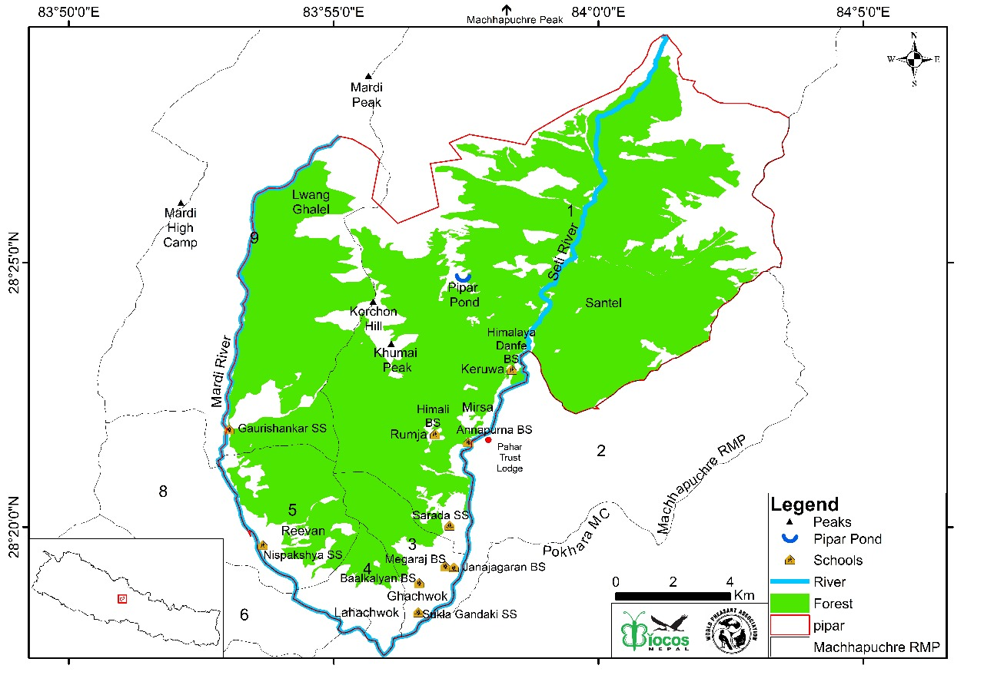
Figure 1: Map of PPCL along with schools where the programs benefited.

Program Implementation

Teacher Training on Conservation Education
From February 12 to 14, 2025, a three-day annual teacher training workshop was held focusing on environmental education and local biodiversity. 13 teachers from 11 schools within the PPCL attended the training. The sessions emphasized the ecological role of local wildlife and strategies for integrating conservation topics into the school curriculum. A key resource introduced was the Junior Conservation Knowledge (JCK) book, which teachers were encouraged to use as a foundational teaching tool. This initiative plays a critical role in linking classroom learning with real-world conservation efforts and ensuring that young students grow up with a solid understanding of local ecology and environmental responsibility. BIOCOS-Nepal also introduced a field-based bird identification technique and concentrated on bird initiatives within the PPCL, highlighting their relevance to ecotourism.

School Visit
This program was conducted by a conservation education program officer, who regularly visited the schools, four times in a year. During each visit the officer would meet with the school administration to discuss conservation education and interacted with the students to raise awareness.

Drawing Competition
An inter-school drawing competition was organized for 5th grade students from WPA-supported schools. The objective was to engage young learners in wildlife conservation through creative expression. Students used the JCK book as a reference, recreating illustrations with a focus on local wildlife. This activity helped students connect more deeply with their local biodiversity and reinforced conservation concepts in an interactive and memorable way. Following the drawing competition, selected students and schools were recognized with prizes to acknowledge their creativity and to encourage continued interest in conservation. This small gesture of appreciation served to motivate students and reinforce the value of their efforts in engaging with environmental topics.

Installation of Awareness Boards
BIOCOS Nepal installed informational boards in key locations throughout the PPCL. These boards highlight the importance of pheasant conservation and the need to protect their habitats. Designed for both community members and visitors, the boards aim to educate the public, foster environmental awareness, and promote active community involvement in ongoing conservation efforts.

Art Program: Pheasant Wall Art in Schools
As part of the awareness initiative, pheasant-themed wall art was created by local artists (Raj Lama) at Shree Danphe Basic School in Karuwa and Sharada Secondary School in Ghachok. These artworks are more than decorative, they serve as engaging educational tools that blend conservation messages with creative expression. The murals depict various pheasant species native to the region and provide both students and the wider community with close, visual familiarity with local wildlife. Teachers can incorporate these murals into their lessons as a reference for discussing biodiversity and local conservation efforts. The integration of art into environmental education has proven to be a powerful way to inspire interest in nature and foster a deeper appreciation for wildlife conservation.

Environmental Awareness Day Out
On January 10, 2025, students from grades 6 to 10, along with teachers from Shree Sharada Secondary School, participated in an environmental awareness hike to Hile kharka. Along the route, participants collected litter and disposed of it in bins placed at 20-minute walking intervals. The hike also featured spontaneous discussions about native plant species and their ecological significance, promoting learning through direct experience. Once they reached Hile kharka, the group shared packed meals in a natural setting, encouraging reflection on their surroundings. As part of the day's activities, students wrote short memory pieces about the experience. One student from each class was awarded a prize for their writing. The event concluded with the group returning to school by the end of the day. The program successfully combined physical activity, environmental stewardship, and creative expression.

Interaction with local communities
The interaction with local communities were more informal, focusing on discussions about biodiversity conservation and highlighting the potential for ecotourism as a benefit of preserving the species and diversity of the area. We have connected with the Annapurna Conservation Area-National Trust for Nature Conservation (along with Conservation Area Management Committee) and had meeting on enhancing the conservation and tourism practices in this region, working collaboratively on the research and patrolling programs. We held discussions with local representatives from Machhapuchre Rural Municipality and its ward regarding improvement of conservation efforts and related programs within the PPCL. Conservation awareness programs centered on both trekking routes that go through the PPCL, the Great Machhapuchre Trail and Machhapuchre Model Trek, were also collaborated on.

Press release on Pheasant survey
On May 3, 2025, a press release on Spring Pheasant Count 2025 (Press Meet and Conservation Awareness Program) was carried out. The goal of the press release was to raise awareness on the status of pheasant conservation, other wildlife conservation, the status of PPCL oriented conservation initiatives, and to promote the bird/wildlife tourism of PPCL. Emphasis was also put on building a strong connection between government and non- government organizations, ensuring that local stakeholders remained the top priority.

Result and Discussion

Teacher Training on Conservation Education
A three-day conservation awareness training program was conducted from 12th to 14th February 2025 (30th Magh to 2nd Falgun, 2081) at Sharada Secondary School, Machhapuchhre Rural Municipality Ward 1, Kaski. The training was organized jointly by BIOCOS-Nepal and WPA Nepal with participation from 13 teachers representing various schools in the Seti River Valley (Table 1). The program aimed to strengthen teachers’ knowledge of wildlife conservation, with a special focus on pheasants and highland biodiversity.
The main objective of the program was to enhance teachers' understanding of wildlife conservation, particularly focusing on pheasants and other key species in the Pipar region. The training emphasized the role of educators in promoting environmental awareness among students and communities living near biodiversity-rich areas. Through this initiative, teachers were introduced to the PPCL and its importance for sustaining Himalayan biodiversity.
Table 1 List of participants and resource persons along with their institutional
Participants
Name | Affiliation
Emmanuel Gurung | Shree Himalaya Danphe Basic School
Maan Bdr. Pun | Shree Himali Basic School
Til kumara Gurung | Shree Annapurna Basic School
Kul Pd. Dahal | Shree Himalay Tinsir Basic School
Yadab Pd. Rgmi | Shree Machhapuchhre Secondary School
Milan Majakoti | Shree Machhapuchhre Secondary School
Sandhaya Jugjali | Shree Sharada Secondary School
Himraj Bhandari | Shree Sharada Secondary School
Anuradha Gaire | Shree Meghrag Basic School
Sabita Bishunke | Shree Janajagaran Basic School
Jiban Acharya | Shree Balkalyan Basic School
Chet Bdr. Ranabhat | Shree Sukla Gandaki Secondary School
Ganga Adhikari | Shree Nispakshya Secondary School
Resource Person
Affiliation (Expertise) | Affiliation (Experties)
Mr. Pawan Rai | BIOCOS Nepal
Ms. Pem Doma Sherpa | WPA
Mr. Man Bahadur Pun | Teacher patrolling representative (Shree Himali Basic School)
Mr. Nabaraj Pokharel | Bird Expert
Mr. Hemanta Dhakal | PhD Scholar, IUCN National Committee
Mr. Lekh Nath Gautam | Annapurna Conservation Area
Mr. Buddhi Bdr. Gurung | BIOCOS Nepal
Mr. Pratik Bhattarai | BIOCOS Nepal
The training covered key topics including an introduction to the Pipar Pheasant Conservation Landscape (PPCL) by Pawan Rai and shared experiences from patrolling efforts and conservation challenges in the Pipar and Khumaidanda areas, presented by Mr. Man Bahadur Pun and local community members. Mr. Rai clarified the research and community support work carried out by WPA Nepal, highlighting the use and importance of the “Junior Conservation Knowledge” (JCK) book as an educational tool. Participants explored how the JCK book could be applied in classrooms and how environmental education supports long-term conservation goals. Nabaraj Pokharel led sessions on bird identification and ecological significance, while Hemanta Dhakal discussed the importance of vulture conservation and related protection strategies. A field trip from Sharada School to Saripakha via Tubu offered hands-on bird identification opportunities and led to the development of a species checklist. Mr. Buddhi Bdr. Gurung, Mr. Pratik Bhattarai, and Mr. Man Bdr. Pun highlighted the importance and technique of SMART patrolling and shared their experience of patrolling in PPCL. The program was concluded by Conservation Officer of ACA, Mr. Lekhnath Gautam who interacted with teachers on the enhancement of conservation education and programs in the school.
Program Opening Session:
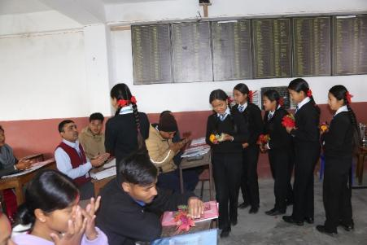 | 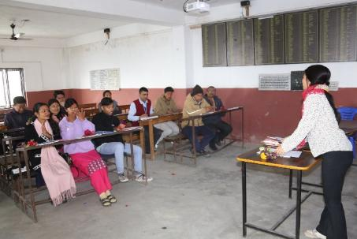
Welcome Program by Sharada School Students | Opening Remarks and Training Orientation
Expert Presentation:
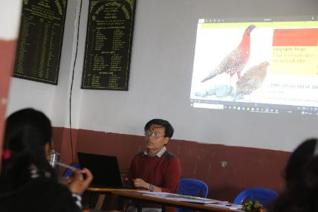 | 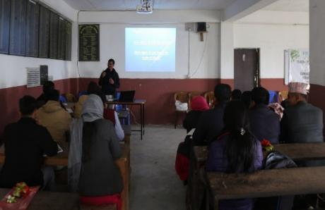
Session by Mr. Pawan Rai | Bird identification techniques and their ecological importance presented by Navaraj Pokharel.
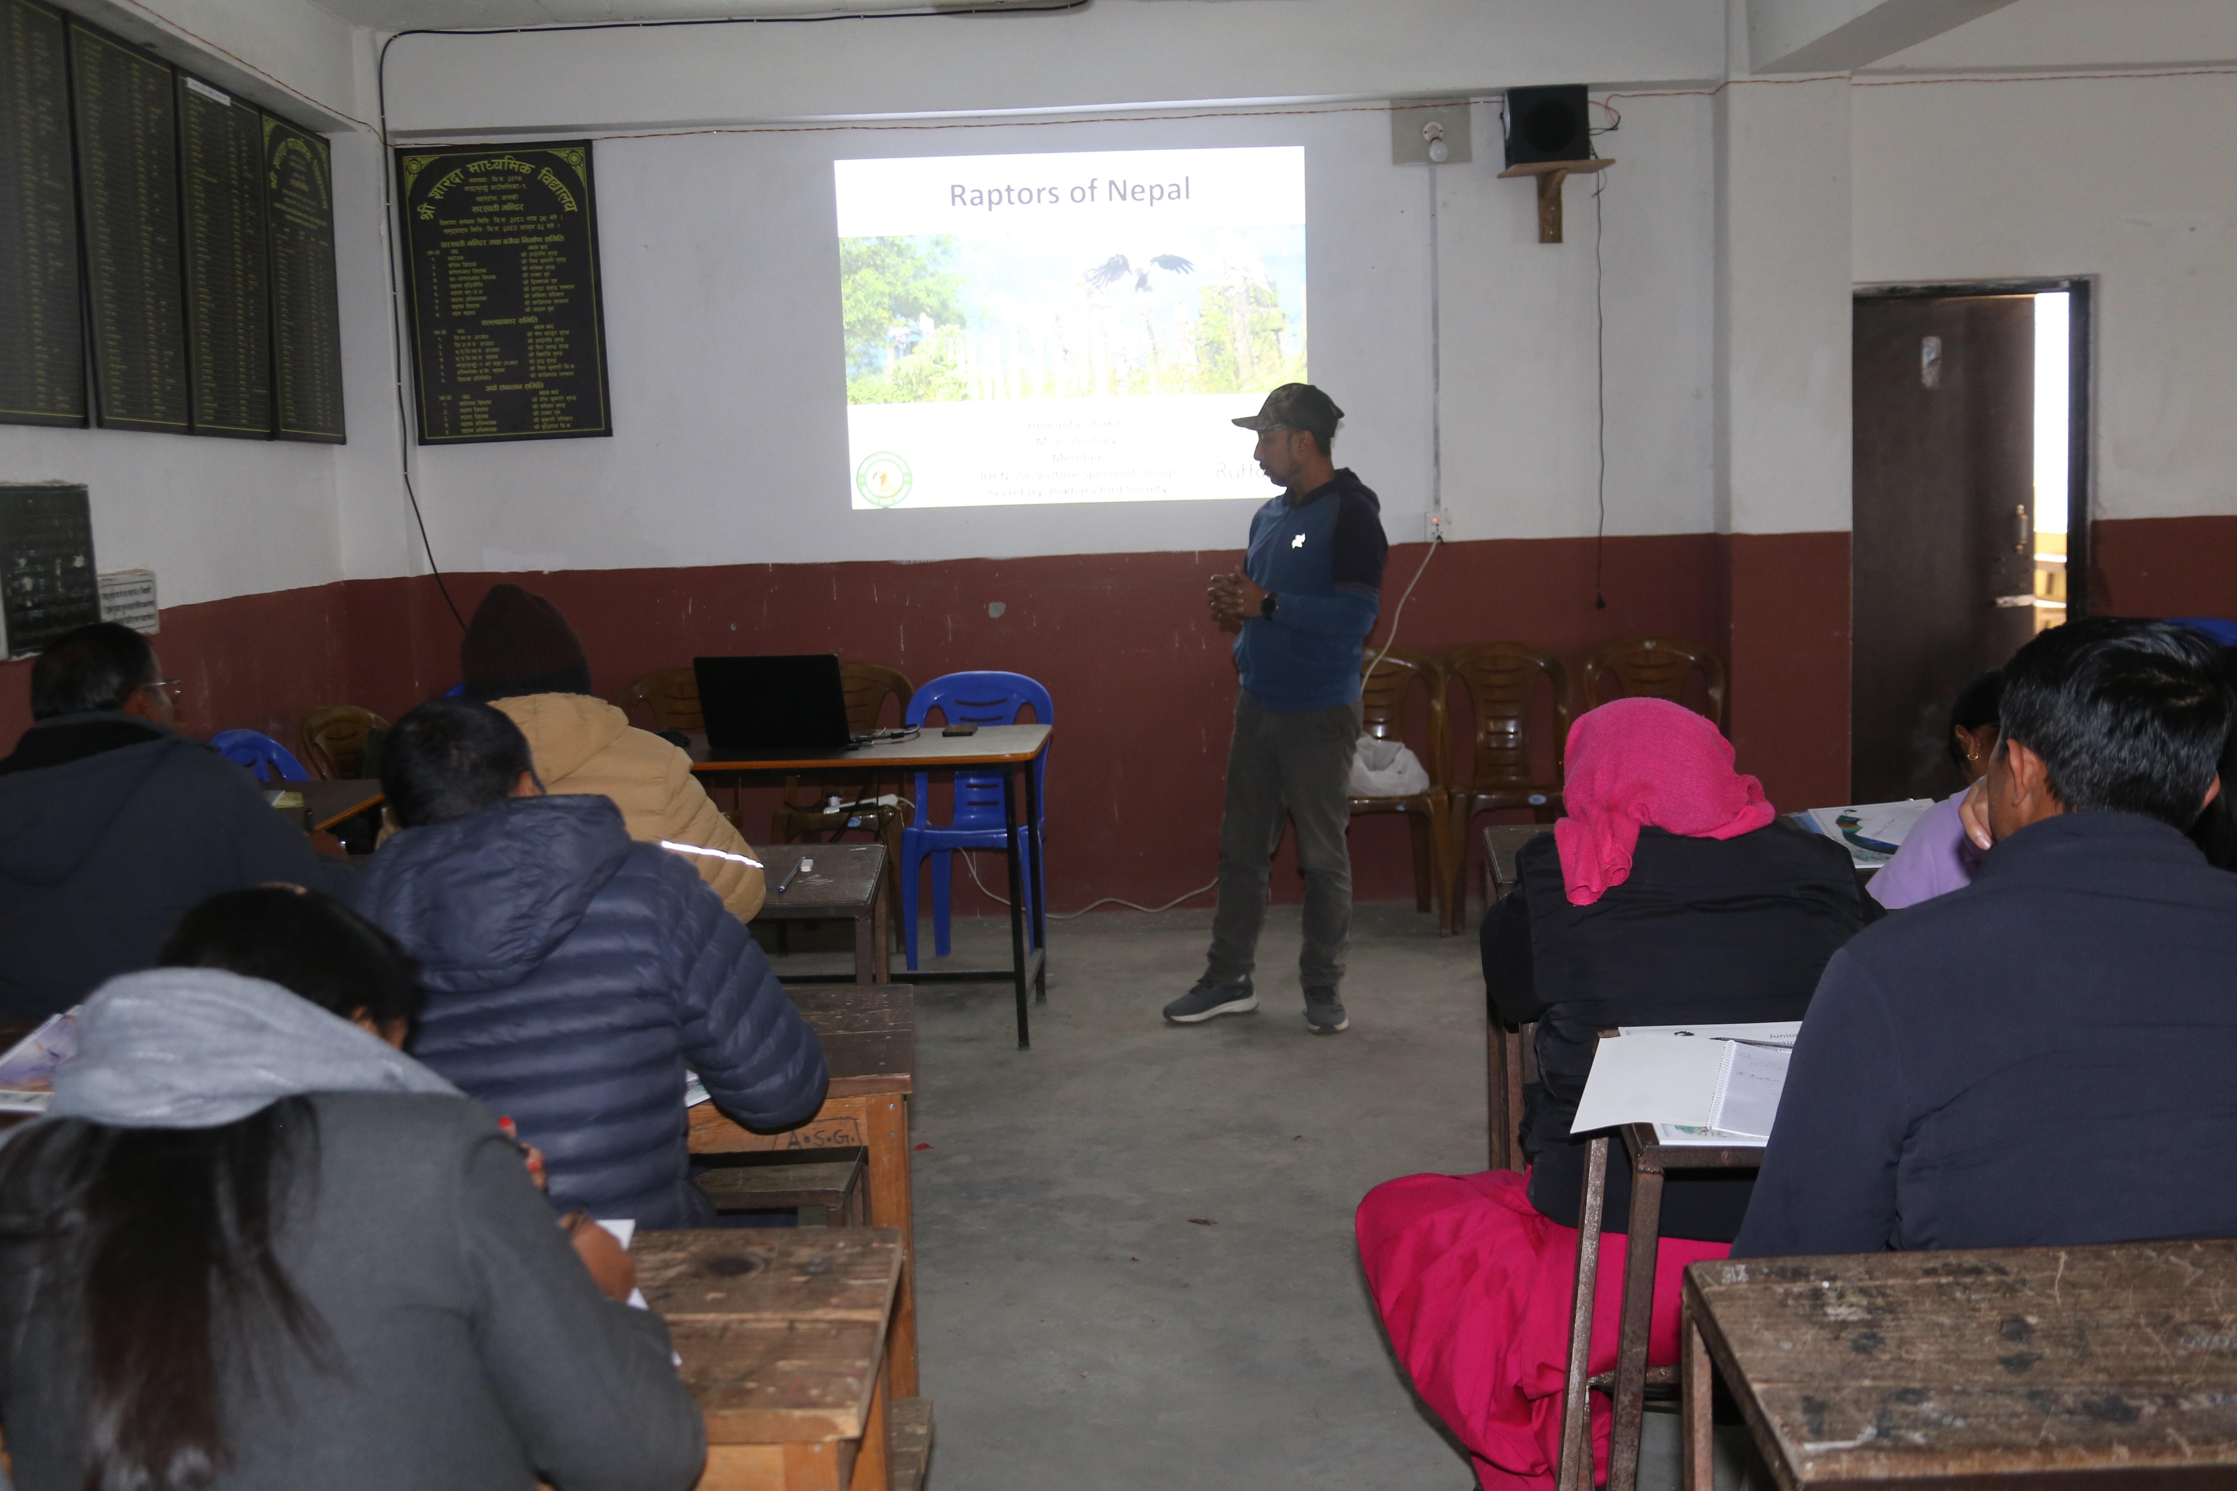 | 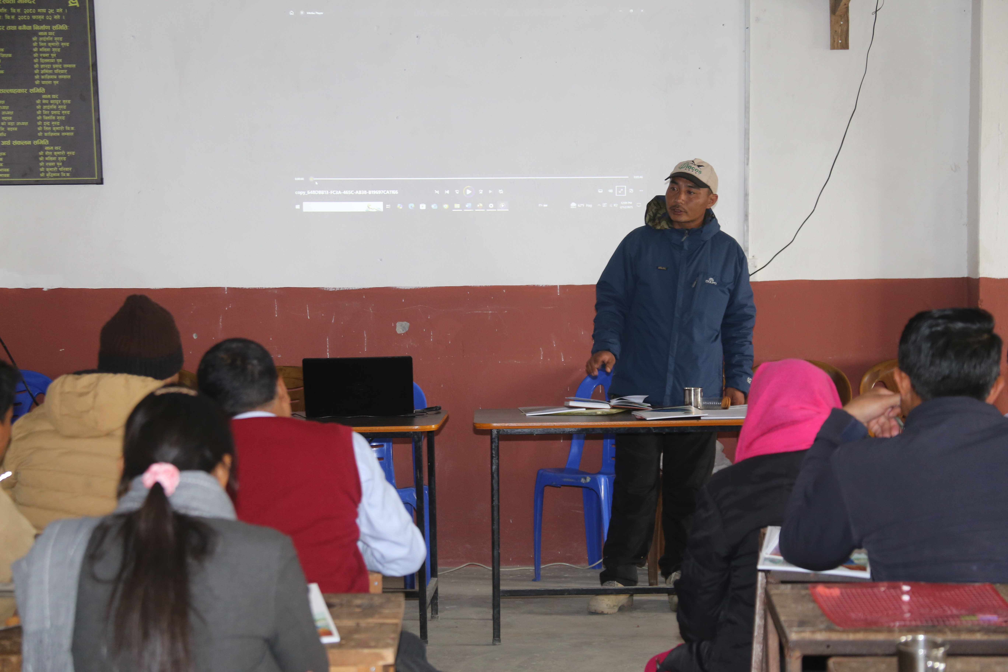
Session by Mr. Hemanta Sharma on raptor importance | SMART Patrolling in PPCL by Mr. Buddhi Bdr. Guruung
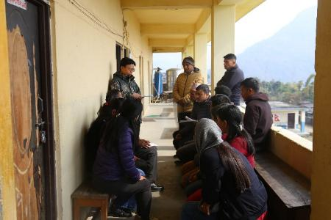 | 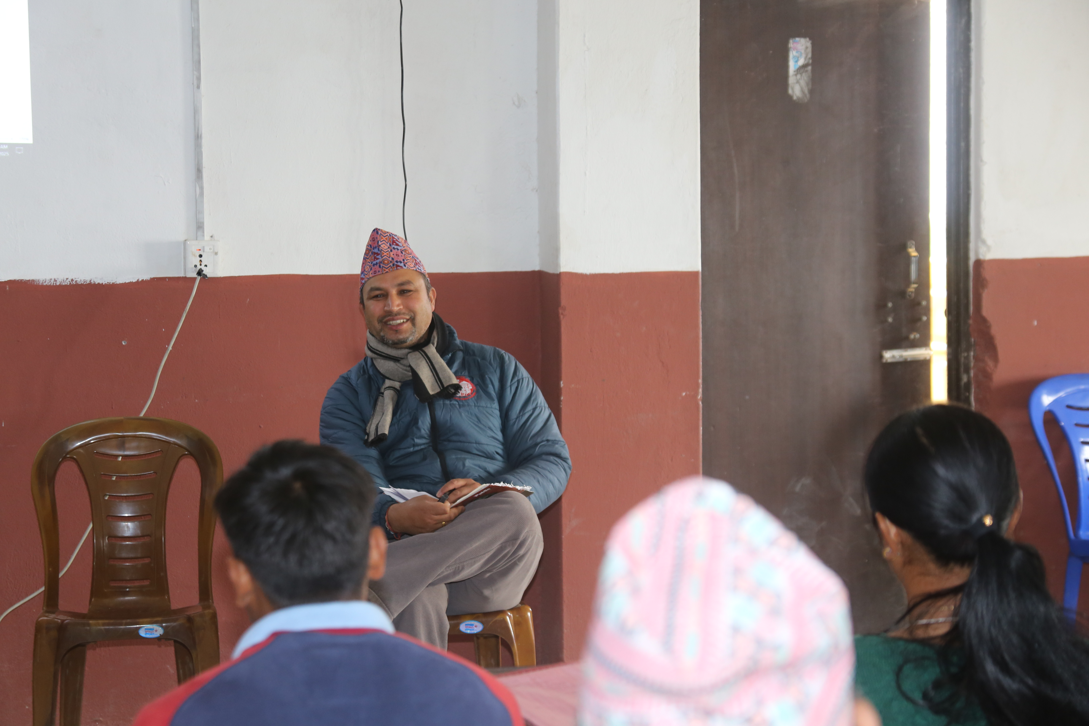
Discussing with teachers on conservation programs for their school | Interaction with Lekhnath Gautam, Conservation Officer, Lawang, ACAP
Field Visit:
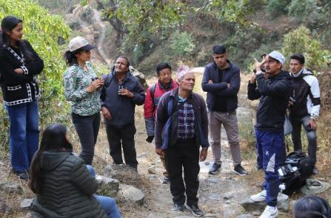 | 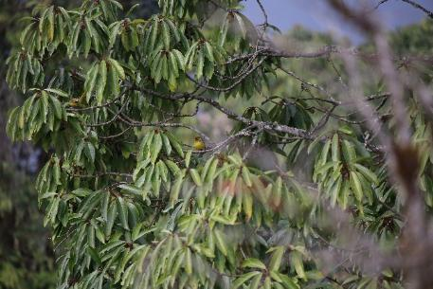
Bird Identification Training and Field Walk | Bird Sighting in Natural Habitat
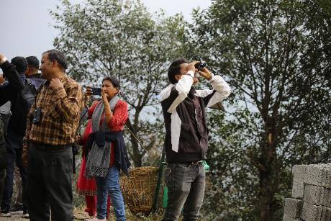 | 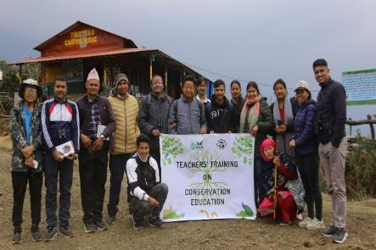
Bird watching in the Field | Participants with our team upon training completion
Closing Ceremony
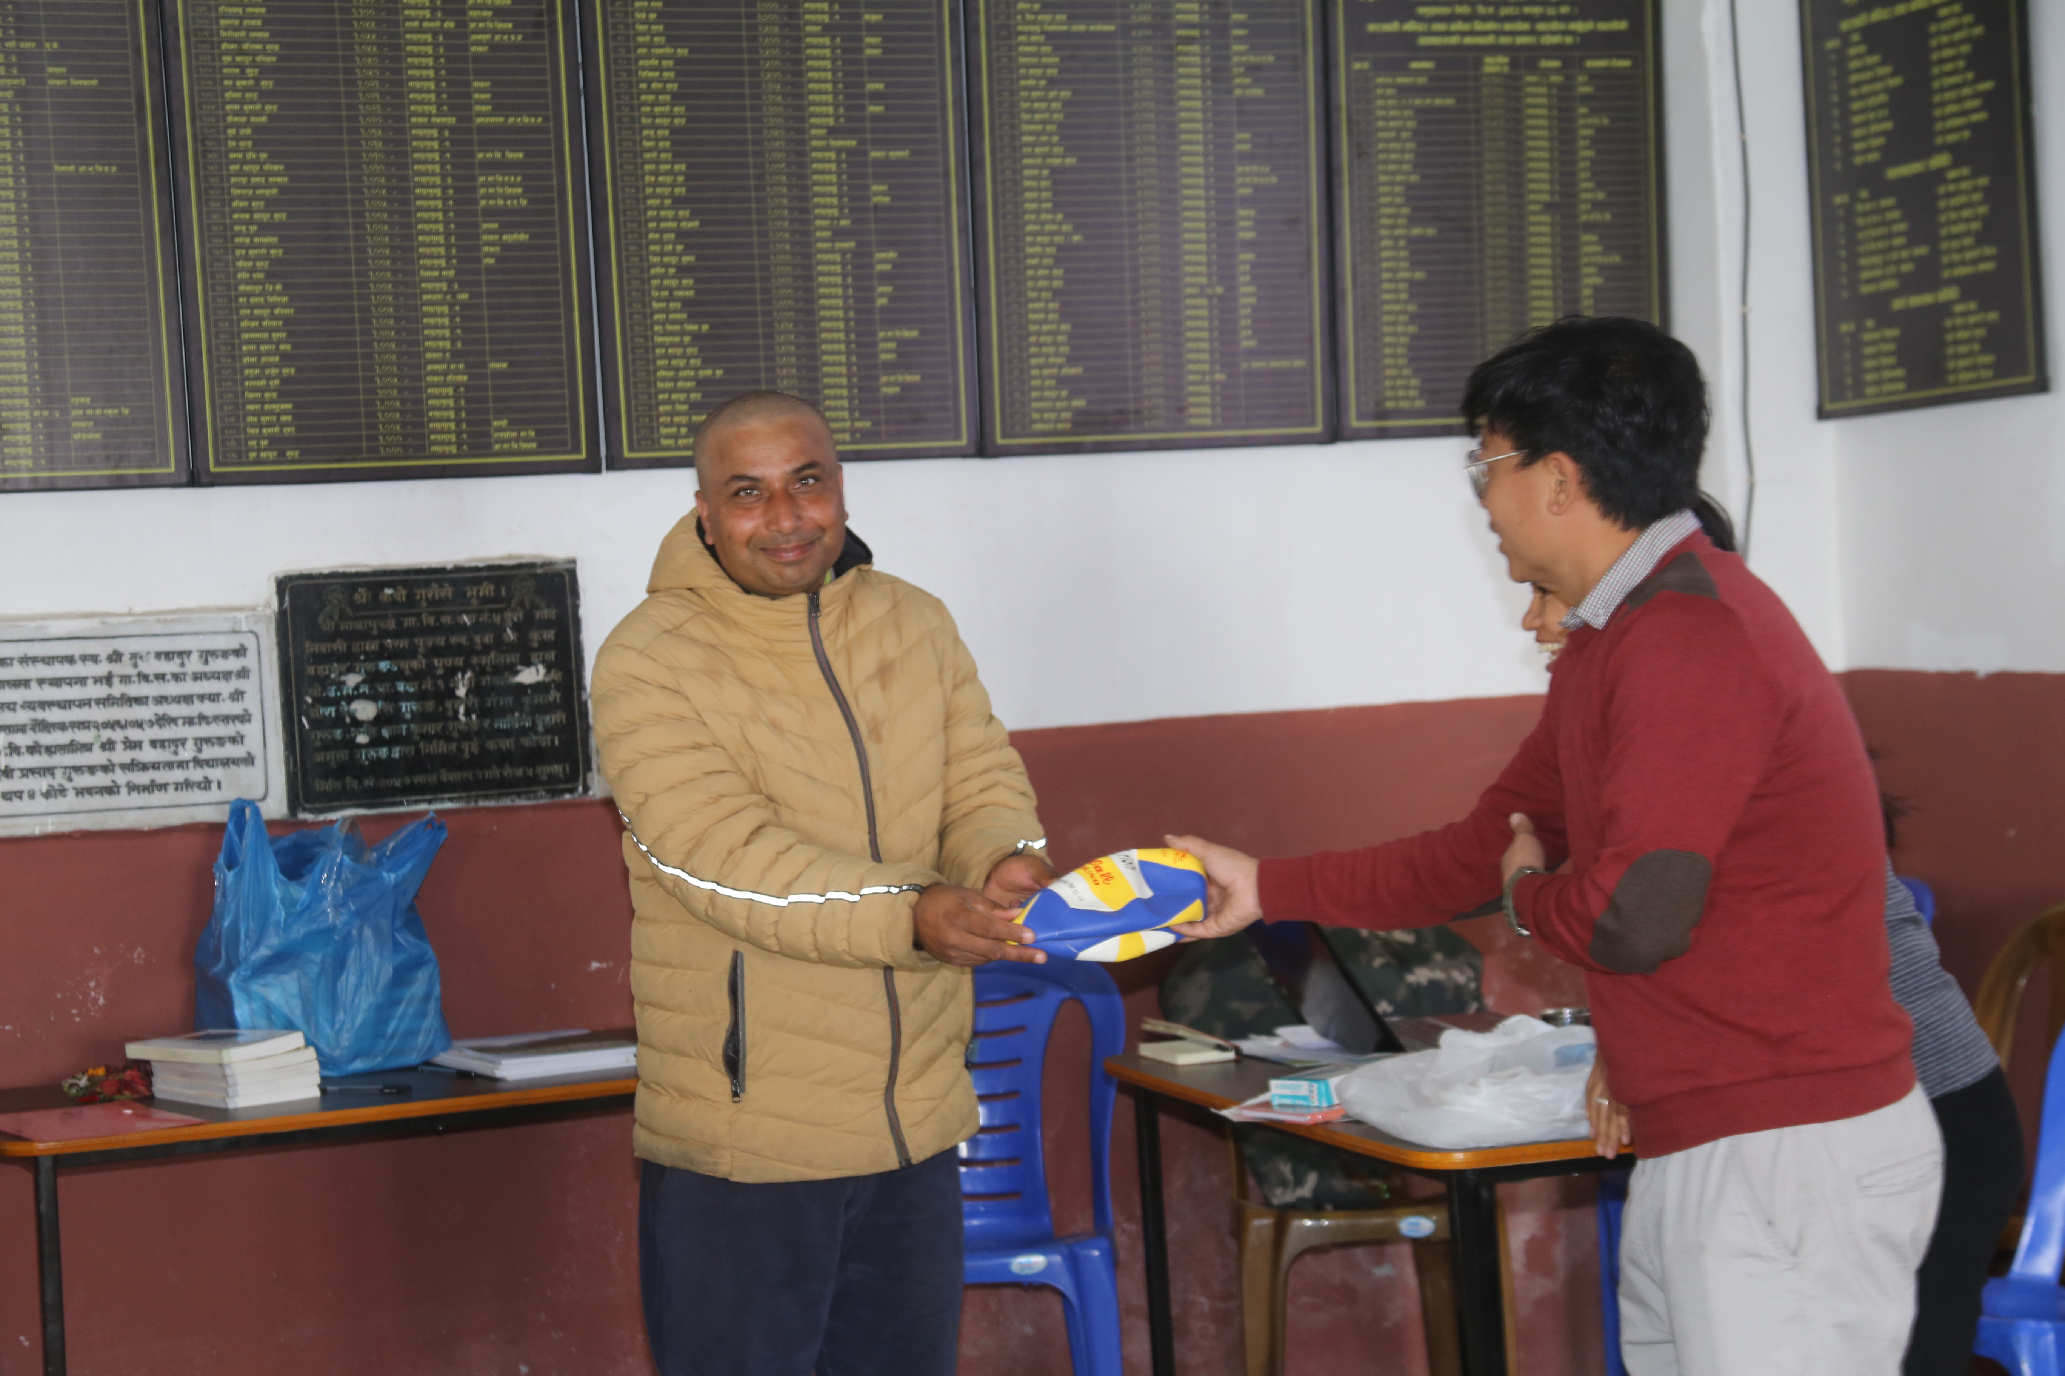 | 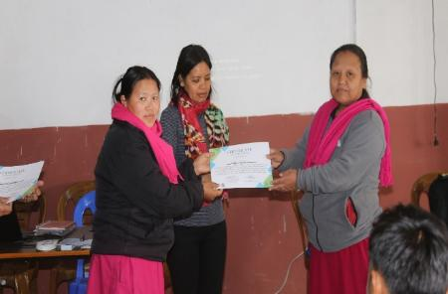
Prize distribution for the inter school drawing competition | Certificate Distribution by Sharada School Principal

School Visit
Conservation education program officer, Pemdoma Sherpa, along with the assistance of other officers, visited all twelve schools at least four times throughout the year. The visits revolved around interaction with members of school management and the inclusion of conservation in school curriculums was discussed. The visits were also aimed at student interaction and the communication of local conservation issues. During the school visits informational posters about the pheasants of Nepal were distributed to the schools and discussed.
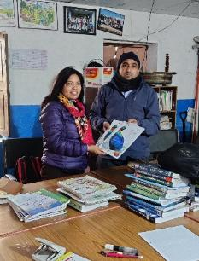 | 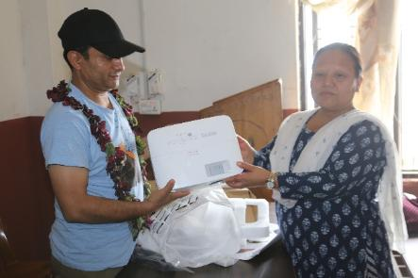
Conservation education officer, Pemdoma Sherpa hand overing JCK to the school management | Dr. Paras B. Singh hand overing Projector to Principle of Shree Sharada Secondary School
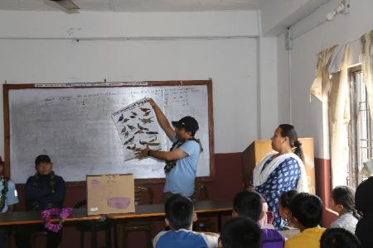 | 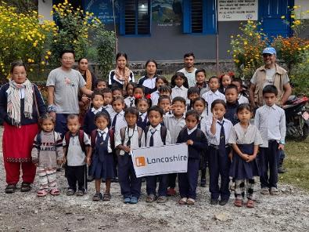
Dr. Singh sharing the poster of pheasants of Nepal to the student and teachers during school visit | School visit at Shree Himalaya Danphe Basic School

Drawing Competition
BIOCOS-Nepal organized a drawing competition among WPA-supported schools, focusing on themes from the Junior Conservation Knowledge Book. The participants were 5th grade students from all participating schools. Most students chose to illustrate the Himalayan Monal, inspired by images from the book. After the drawing sessions, all artwork was collected and reviewed. One student from each school was shortlisted based on creativity and accuracy, and among them, a single best entry was selected. Prizes were awarded to the top student as well to those who made it to the final selection list. The activity aimed to foster awareness and interest in wildlife conservation through creative expression.
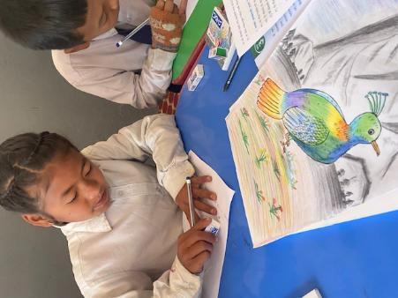 | 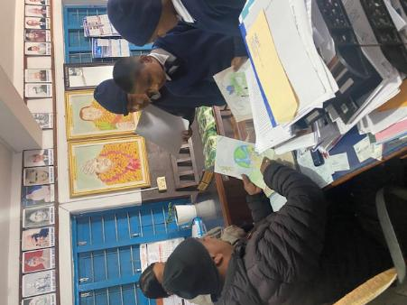
Student taking part in drawing competition | Selection of winner from the school
 | 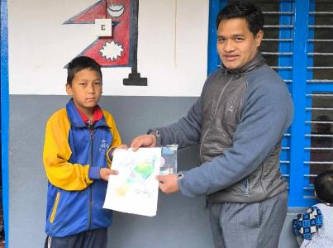
Materials for the drawing competetion | Winner from Shree Himalay Danphe School
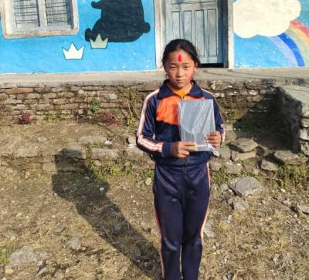 | 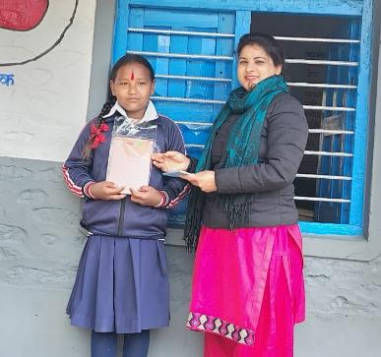
Winner from Shree Himalaya Tinssir Basic School | Wi****ner from Shree Annapurna Basic School
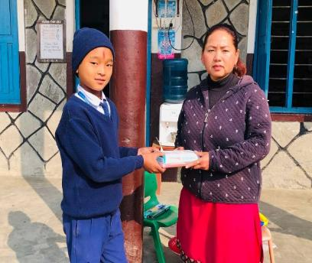 | 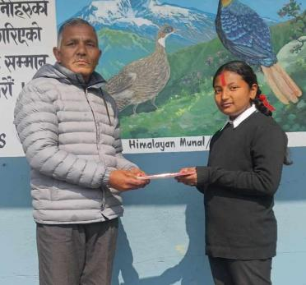
Winner from Shree Machhapuchhre Secondary School | Winner from Shree Sharada secondary school
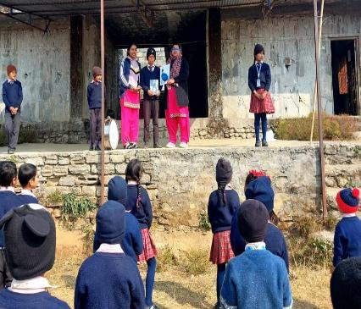 | 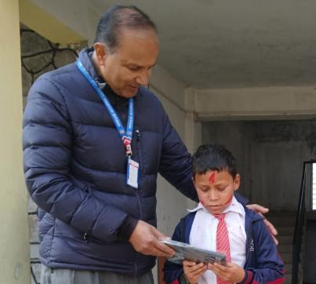
Winner from Shree Janajagaran Basic School | Winner from Shree SuklaGandaki Secondary School
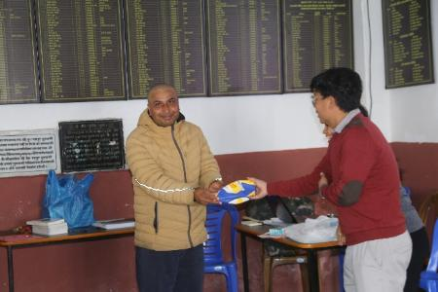 | 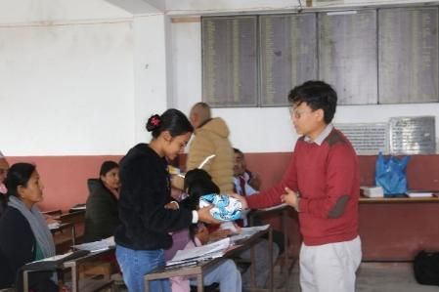
Prize Ceremony for Drawing Competition Winner | Prize Ceremony for Drawing Competition Winner

Installation of Awareness Boards
The awareness board in the figure below was prepared as part of a conservation initiative by BIOCOS-Nepal, in collaboration with the WPA, Annapurna Conservation Area Project (ACAP), and other local stakeholders. We had installed board at two different locations in an effort to reach a wider audience. One of the boards was installed at the Karuwa and another at Tubu. These boards serve as a visible and informative tool ideal for community settings. They educate residents and visitors alike about the importance of pheasant conservation, encourages responsible behaviour in wildlife areas, and invites collective action to protect Nepal’s avian heritage.
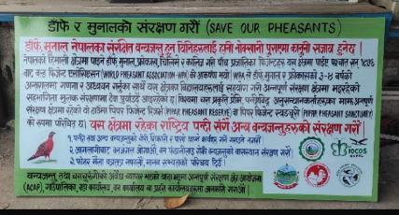 | 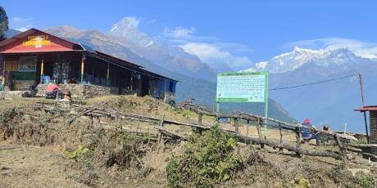
Community Awareness Board on Pheasant Conservation | Pheasant Conservation Awareness Board Installed in Tubu

Art Program: Pheasant Wall Art in Schools
At Shree Himalaya Danphe Basic School and Shree Sharada Secondary School, vibrant wall art featuring colourful pheasants has been created as part of the conservation awareness initiative. These murals, painted directly onto school walls, depict native pheasant species in rich, eye-catching detail. Beyond their visual appeal, the artwork serves as a powerful educational tool, sparking curiosity among students and encouraging them to learn about and protect local wildlife. The presence of these lively pheasant images helps instil a sense of pride and responsibility, making conservation a visible and engaging part of the everyday school environment.
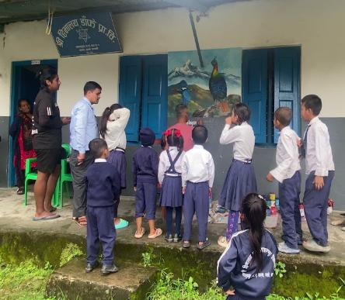 | 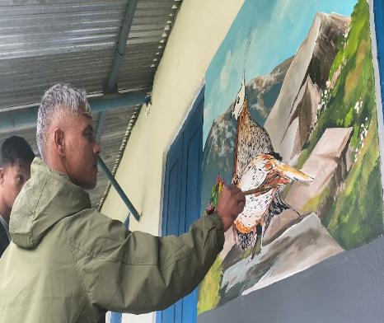
Shree Himalaya Danphe Basic School Karuwa | Teacher in Action: Bringing Pheasants to the Classroom Wall
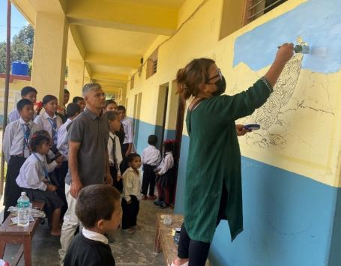 | 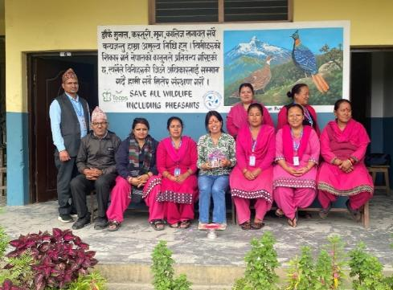
Teacher Painting Pheasant Mural to Inspire Conservation | Teachers of Shree Sharada Secondary School

Environmental Awareness Day Out
On January 10, 2025, Shree Sharada Secondary School organized an environmental awareness day for students of class 6 to 10, with 74 participants including teachers and guests. The group hiked to Hile kharka, collecting litter along the way and engaged in discussions about local plants and ecology. After reaching the site, students shared lunch and took part in a memory-writing activity, with one student from each class awarded for their reflections. The event combined environmental education, hands-on learning, and creative expression, leaving a lasting impression on both students and teachers.
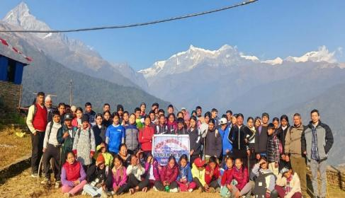 | 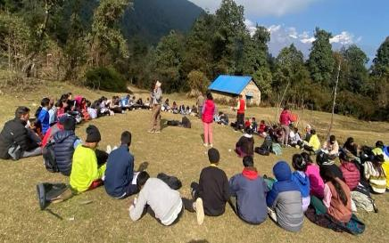
Group Photo of Awareness Team with Mt. Fishtail and Annapurna Range from Tubu | Students Participating in Memory Writing Competition
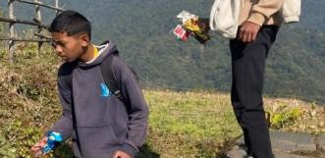 | 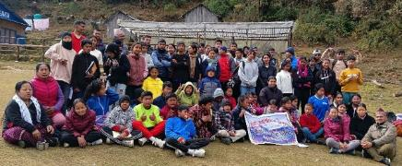
Students Collecting Litter During Awareness Walk in Saripakha | Group Photo at Hilekharka Before Returning to School

Interaction with local communities
The regular consultation with official representatives from Machhapuchre Rural municipality, Wards, ACA, CAMC, GMT and GMT was carried out. Every time we visited a research site, we interacted with the local people; herders, hotel and homestay owners, and farmers to understand their perceptions of the local conservation climates, which gave us valuable and guidance.
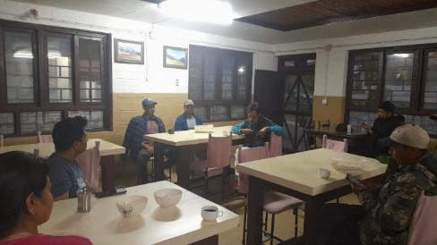 | 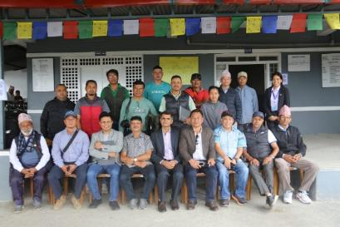
Interacting during the planning of pheasant survey 2025 | Group photo with representatives of ACA, RMP, CAMCs, GMT and hoteliers.
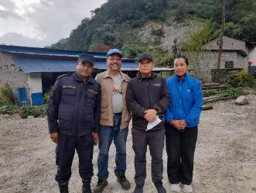
Mr. Laxman Pd. Poudyal with ACA team and police (Photo: Pawan Rai)

Press release on Pheasant survey
The Press Meet and Conservation Awareness Program was conducted on the 3rd of May, 2025 where 80 persons attended the program. The participants includes representatives of ACA, RMP, CAMCs, GMT, hoteliers, teachers, scouts, and nationally recognized newspaper reporters. This event was targeted first and foremost at bringing awareness to the status of pheasant and other wildlife conservation, current programs statuses going on in PPCL, and to promote bird/wildlife tourism within the area. This program also emphasis on the connection of different stakeholders from government to non-governmental organizations keeping local stakeholders on priority.
Dr. Singh from BIOCOS Nepal highlighted the current status of the PPCL and possibilities of the landscape. Bird experts Mr. Hatan Mahato and Mr. Manashant Ghimire highlighted the importance of the iconic birds of the PPCL and the probabilities of bird/wildlife. Mr. Rabin Kadariya, Project Chief of ACA spoke on the conservation tourism and promotion of PPCL to the bird enthusiast community as well. As representatives of RMP, chairman Mr. Min Bdr. Gurung, and chairman Mr. Birendra Gurung spoke on the management of the landscape and the effect of tourism sector activities such as trekking

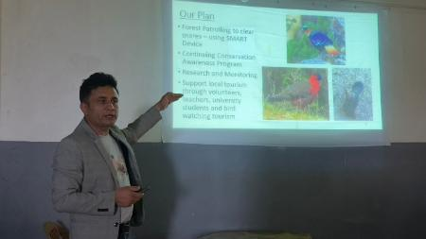 | 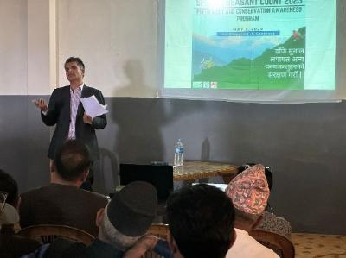
Dr. Singh presenting the plans for PPCL | Mr. Kadariya sharing his words on the press meet
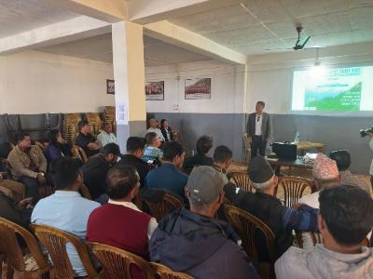 | 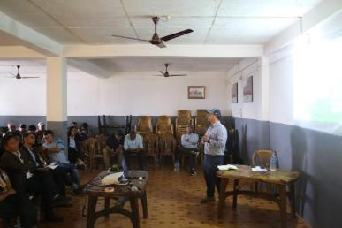
Chairman of Machhapuchre RMP | Chairman of ward 1
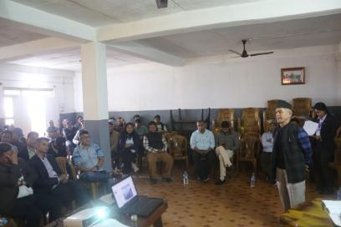 | 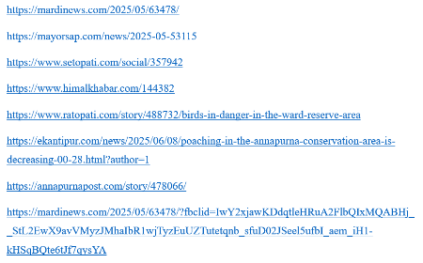
Chairman of CAMC | Some links of news article published after press meet

Key outputs and achievements of conservation education program
- The long-standing involvement of the World Pheasant Association (WPA) in the region—dating back to the 1970s—was presented to local stakeholders, helping to build trust and increasing awareness and community support for ongoing and future conservation initiatives.
- The program served as a platform to introduce the collaborative efforts of BIOCOS-Nepal and WPA to a broader audience, strengthening relationships between conservation organizations and the local community.
- A formal declaration at the conclusion of the teacher training workshop clearly defined the role of educators in contributing to local wildlife conservation, particularly in protecting pheasants.
- Teachers gained practical skills in bird identification and deepened their understanding of environmental and conservation issues relevant to the Pipar landscape.
- Many educators expressed their willingness to support and engage in future conservation initiatives led by WPA and BIOCOS-Nepal, particularly those focusing on pheasant protection.
- Conservation education activities raised awareness among students and local residents about Pipar’s ecological value and its future as a biodiversity-rich landscape.
- The initiative contributed to early environmental education by equipping both students and teachers with foundational knowledge about pheasants, wildlife, and sustainable conservation practices.
- More than 200 students from Grades 4 to 6 were introduced to critical conservation themes—such as pheasant biology, habitat importance, and threats—topics often not covered in standard school curricula.
- Students living near forests revealed some awareness of hunting and wildlife trade but lacked knowledge of their legal consequences. The program successfully addressed this gap through targeted messaging.
- An inter-school drawing competition inspired students to creatively engage with the theme of pheasant conservation, using the JCK book as a learning resource to deepen their understanding.
- Recognition was given to both participating and non-participating schools through a fair distribution of prizes, encouraging broader student involvement in conservation-themed activities.
- A guided uphill nature walk with students from Shree Sharada Secondary School helped instill a deeper connection to the natural world, sparking interest in replicating such outdoor learning experiences in other schools.
- A visually striking mural of a pheasant on a school wall served as an educational tool and a symbol of conservation, introducing students and visitors to the species and the supporting organizations.
- Public awareness boards were installed along the routes to Pipar and Khumai, conveying essential conservation messages in both Nepali and English, making the content accessible to both local residents and visiting tourists.
- The program facilitated meaningful interactions between local people, school communities, conservation staff, and visiting organizations—encouraging shared ownership of wildlife protection efforts.
- Community support for the conservation of pheasants and other wildlife species in the PPCL was notably strengthened.
- The initiatives sparked local interest in improving habitats to support growing pheasant populations.
- The activities collectively promoted Pipar as a site of high biodiversity value and as a promising destination for eco-tourism and nature-based learning.
- Local communities were encouraged to take greater responsibility for preserving their wildlife and natural heritage.
- The vision of developing bird and wildlife tourism in the PPCL was embraced by community members, who committed themselves to continued support and stewardship of the region’s natural assets.

Conclusion and Recommendation

Conclusion
The initiatives jointly implemented by BIOCOS-Nepal and WPA reflect how targeted community-based conservation education can foster lasting awareness and engagement. By involving students, teachers, local leaders, tourism entrepreneurs and broader community members, the program has successfully promoted the understanding of pheasant conservation and the broader importance of biodiversity in the PPCL region. Creative approaches like school wall art, environmental walks, and drawing competitions connected young minds to nature, while teacher training and the use of the Junior Conservationist Book enabled educators with the tools necessary to integrate conservation into everyday learning. The visible enthusiasm from local residents and their willingness to collaborate on habitat management and species monitoring shows a promising shift in local attitudes. Still, sustained awareness efforts are essential to reinforce these values and ensure long-term commitment. These early steps have laid a strong foundation for a conservation-minded community that can carry forward the protection of Nepal’s rich natural heritage.

Recommendation
The conservation efforts led by WPA and BIOCOS-Nepal in the Pipar region have created a strong foundation for protecting Himalayan pheasants and their habitats. However, to ensure long-term sustainability and to address ongoing challenges, the following recommendations are proposed:
- Strengthen Anti-Poaching Measures: Poaching remains one of the major threats to pheasant populations. Anti-poaching efforts should be intensified through regular patrolling in known hotspots. Engaging local communities in monitoring and reporting illegal activities is key, and a community-based reward systems for credible information could further strengthen this. In addition, modern tools like camera traps and drones can be introduced for better surveillance.
- Expand Conservation Education: Integrate environmental education more deeply into school curriculums and conduct regular workshops for students and teachers. Educating the younger generation is one of the most sustainable ways to build long-term conservation ethics.
- Improve Communication and Transparency: All conservation organizations working in the area should actively share their work and findings with local communities. This kind of transparency can bridge gaps between stakeholders, build trust, and lead to more effective collaboration and outcomes.
- Engage Schools and the Wider Public: Schools located around conservation areas should be consistently involved in awareness programs, as they play a key role in spreading knowledge at the community level. Similarly, public-facing materials such as publications, signage, and display boards should be used to educate both locals and visitors.
- Institutionalize Awareness and Community Programs: WPA and BIOCOS-Nepal should continue running awareness programs on a regular basis. These should go beyond one-time events and focus on long-term community engagement, including working closely with local government bodies.
- Influence Policy and Promote Eco-Tourism: Conservation efforts need support at the policy level. Engaging with policymakers to advocate for eco-tourism and conservation-friendly policies within the Pipar landscape is crucial. Government involvement can help scale up the impact and ensure that conservation remains a long-term priority.

Annex

Annex1: Program schedule of teacher’s training held in February 2025.
DATE | Time | Activities | Facilitator
12-Feb | 10:00-10:15 | Registration | Ms. Pemdoma
12-Feb | 10:15-10:30 | Ice Breaker | Ms. Pemdoma
12-Feb | 10:30-10:45 | Overview of the program | Mr. Pawan
12-Feb | 10:45-11:30 | Introduction to PPCL | Mr. Pawan Rai
12-Feb | 11:30-12:00 | Sharing of Patrolling in Khumai Route | Mr.Man B. & Mr. Min B., Mr. Buddhi / Mr. Pawan
12-Feb | 12:00-14:00 | Bird Identification Technique | Mr. Nabaraj
12-Feb | 14:00-14:30 | Lunch Break
12-Feb | 14:00-14:30 | Book Overview (Application, challenge, recommendation) JCK | Mr. Pawan
12-Feb | 14:30-15:30 | Vulture Conservation | Mr. Hemanta
12-Feb | 15:30-16:00 | Introduction to Forest scout of PPCL and Patrolling | Mr. Buddhi /Mr.Pratik
Feb 13 | 10:05-11:00 | school programs for environmental issues | Mr. Pawan/ Ms. Pemdoma
Feb 13 | 11:00-11:30 | School Program Discussion (our program) | Mr. Pawan/ Ms. Pemdoma
Feb 13 | 11:30-12:00 | Pollution In Rural area | Mr. Pawan
Feb 13 | 11:30-13:30-15:30 | 2 hrs. to Tubu and lunch and return plant and Birding | Mr. Pawan/ Ms. Pemdoma
Feb 14 | 10:05-11:00 | Checklist of birds | Ms. Pawan
Feb 14 | 11:00-11:30 | school programs for environmental issues | Mr. Pawan/ Ms. Pemdoma
Feb 14 | 11:30-12:00 | ACAP Officer | ACAP/NTNC
Feb 14 | 12:30-14:00 | (Municipality Officer, ACA) Group Discussion about school participation in Conservation | ACAP/NTNC
Feb 14 | 14:00-14:10 | Prize distribution for school drawing competition

Annex 2: Bird Checklist prepared by teachers during field visit during the training
S.N. | Common Name | Scientific Name
1 | Rock Pigeon (Feral Pigeon) | Columba livia
2 | Oriental Turtle-Dove | Streptopelia orientalis
3 | White-rumped Vulture | Gyps bengalensis
4 | Shikra | Tachyspiza badia
5 | Black Kite | Milvus migrans
6 | Great Barbet | Psilopogon virens
7 | Green-backed Tit | Parus monticolus
8 | Himalayan Black-lored Tit | Machlolophus xanthogenys
9 | Barn Swallow | Hirundo rustica
10 | Red-vented Bulbul | Pycnonotus cafer
11 | Himalayan Bulbul | Pycnonotus leucogenys
12 | Gray-hooded Warbler | Phylloscopus xanthoschistos
13 | Whiskered Yuhina | Yuhina flavicollis
14 | Streaked Laughingthrush | Trochalopteron lineatum
15 | Rufous Sibia | Heterophasia capistrata
16 | Chestnut-tailed Minla | Actinodura strigula
17 | White-crested Laughingthrush | Garrulax leucolophus
18 | Common Myna | Acridotheres tristis
19 | Small Niltava | Niltava macgrigoriae
20 | Golden Bush-Robin | Tarsiger chrysaeus
21 | Blue-fronted Redstart | Phoenicurus frontalis
22 | Fire-breasted Flowerpecker | Dicaeum ignipectus
23 | Orange-bellied Leafbird | Chloropsis hardwickii
24 | Eurasian Tree Sparrow | Passer montanus
25 | Olive-backed Pipit | Anthus hodgsoni
26 | Common Rosefinch | Carpodacus erythrinus
27 | Pink-browed/Himalayan White-browed Rosefinch | Carpodacus rodochroa/thura
28 | Dark-breasted Rosefinch | Procarduelis nipalensis
29 | Oriental Magpie Robin | Copsychus saularis
30 | Jungle Myna | Acridotheres fuscus
31 | Rufous Treepie | Dendrocitta vagabunda
32 | Long-tailed Shrike | Lanius schach
33 | Rose-ringed Parakeet | Psittacula krameri
34 | Spotted Dove | Spilopelia chinensis

Annex 3: list of news articles
https://mardinews.com/2025/05/63478/
https://mayorsap.com/news/2025-05-53115
https://www.setopati.com/social/357942
https://www.himalkhabar.com/144382
https://www.ratopati.com/story/488732/birds-in-danger-in-the-ward-reserve-area
https://ekantipur.com/news/2025/06/08/poaching-in-the-annapurna-conservation-area-is-decreasing-00-28.html?author=1
https://annapurnapost.com/story/478066/
https://mardinews.com/2025/05/63478/?fbclid=IwY2xjawKDdqtleHRuA2FlbQIxMQABHj__StL2EwX9avVMyzJMhaIbR1wjTyzEuUZTutetqnb_sfuD02JSeel5ufbI_aem_iH1-kHSqBQte6tJf7qysYA

