ANNUAL REPORT 2025

Submitted to:
Biodiversity Conservation Society Nepal (BIOCOS-Nepal)

Prepared by:
Larisha Gautam

February, 2026


ACKNOWLEDGEMENT
BIOCOS–Nepal sincerely acknowledges the generous support, collaboration, and commitment of numerous organizations, institutions, and individuals who contributed to the successful implementation of our conservation programs during 2025. The achievements documented in this annual report would not have been possible without their collective efforts and continued trust.
We express our deep gratitude to our funding and technical partners, particularly the World Pheasant Association (WPA), Toledo Zoo and Aquarium, Sioux Falls Zoo and Aquarium (USA), and supporting institutions whose financial assistance and guidance enabled the effective implementation of wildlife research, monitoring, and community-based conservation activities across multiple landscapes.
Our sincere appreciation goes to the Department of National Parks and Wildlife Conservation (DNPWC), the Annapurna Conservation Area Project (ACAP), and the National Trust for Nature Conservation (NTNC) for granting permissions, providing institutional backing, and facilitating field activities within protected and conservation areas. The support of ACAP field offices, and their staff was instrumental in ensuring smooth coordination and on-ground implementation of surveys, monitoring programs, and community activities.
We are grateful to rural municipalities, ward offices, Conservation Area Management Committees, and Community Forest User Groups in Myagdi, Mustang, Manang, Kaski, and surrounding districts for their cooperation and encouragement. Their active involvement strengthened local ownership and helped integrate conservation efforts with local governance and community priorities.
BIOCOS–Nepal also extends heartfelt thanks to local communities, herders. Their hospitality, local knowledge, and willingness to work alongside conservation teams played a vital role in field surveys, patrols, and awareness activities.
We acknowledge the dedication and hard work of local scouts, rangers, field assistants, and volunteers, whose tireless efforts in patrolling, camera trapping, biodiversity surveys, and data collection formed the backbone of many programs. Special appreciation is extended to individuals who supported field logistics, data analysis, botanical surveys, and technical reporting.
Our sincere thanks also go to women’s groups (Aama Samuha), youth groups, teachers, and students, whose enthusiastic participation in awareness programs and community events, including sports and culture-based initiatives, demonstrated the power of inclusive and locally driven conservation approaches.
Finally, we would like to acknowledge the unwavering commitment of the BIOCOS–Nepal team, whose professionalism, teamwork, and dedication ensured the successful execution of diverse conservation activities throughout the year. The collective contributions of all partners and stakeholders have strengthened conservation outcomes and laid a solid foundation for continued efforts toward biodiversity protection and community stewardship in Nepal.
TABLE OF CONTENTS

ACKNOWLEDGEMENT ii
CHAPTER 1: INTRODUCTION 1
1.1. Background 1
CHAPTER 2: WORKING AREA 2
2.1. Round Dhaulagiri Conservation Program 2
2.2. Pipar Pheasant Conservation Landscape (PPCL) 2
2.3. Snow Leopard Stewardship Program 2
CHAPTER 3: ACTIVITIES 3
3.1. Round Dhaulagiri Conservation Program 3
3.2. Pipar Pheasant Conservation Landscape (PPCL) 4
3.2.1. Camera Trap Program 4
3.2.2. SMART (Spatial Monitoring and Reporting Tool) Monitoring 6
3.2.3 Bird Survey 7
3.2.4. Vegetation and Human Disturbance Assessment 9
3.2.5. Munal Volleyball Cup 10
3.2.6. Conservation Awareness Programs 11
3.3. Snow Leopard Stewardship Program 12
CHAPTER 4: CONCLUSION 13
4.1. Conclusion 13
Annex 14

LIST OF FIGURES

Figure 1: Map showing the Round Dhaulagiri Conservation Program area in Myagdi District 2
Figure 2: Map showing the Pipar Pheasant Conservation Landscape (PPCL), a key working area where multiple conservation programs were implemented during 2025. 2
Figure 3:Figure 3 Extended SLSP area: Lower mustang, Neshyang valley and Nar-Phoo valley 2

ACRONYMS AND ABBREVIATIONS
ACA | Annapurna Conservation Area
ACAP | Annapurna Conservation Area Project
BIOCOS–Nepal | Biodiversity Conservation Society–Nepal
CAMC | Conservation Area Management Committee
CITES | Convention on International Trade in Endangered Species of Wild Fauna and Flora
DD | Data Deficient (IUCN Red List Category)
EN | Endangered (IUCN Red List Category)
GMT | Green Mountaineering Trekking
GPS | Global Positioning System
IUCN | International Union for Conservation of Nature
LC | Least Concern (IUCN Red List Category)
NT | Near Threatened (IUCN Red List Category)
PA | Protected Area
PPCL | Pipar Pheasant Conservation Landscape
RM | Rural Municipality
Schedule-I | Schedule-I of Nepal’s National Parks and Wildlife Conservation Act
SLH | Snow Leopard Haven
SLSP | Snow Leopard Stewardship Program
SMART | Spatial Monitoring and Reporting Tool
VU | Vulnerable (IUCN Red List Category)
WPA | World Pheasant Association

CHAPTER 1: INTRODUCTION

Background
The Biodiversity Conservation Society Nepal (BIOCOS Nepal) was established as a non-governmental, non-profit organization to address these ecological challenges through a balanced approach of rigorous scientific research and grassroots community engagement. Based in Lalitpur, it focuses on the preservation of high-altitude ecosystems and the survival of endangered "flagship" species, most notably the Snow Leopard (Panthera uncia), Red Panda (Ailurus fulgens), and Pheasants (Himalayan Monal, Satyr Tragopan). While research plays an important role in guiding our efforts, it places equal emphasis on working directly with communities. By training citizen scientists, organizing field activities, and supporting local monitoring efforts, it creates opportunities for people to connect with wildlife, understand the challenges these species face, and take part in protecting them. It also runs awareness campaigns, school programs, workshops, and events that encourage participation from youth, local leaders, and other stakeholders. Activities are designed to be interactive, practical, and enjoyable, helping communities understand the value of their natural surroundings and inspiring them to take ownership of conservation efforts.
Over the past year, BIOCOS-Nepal has worked closely with local authorities, partner organizations, and community groups across multiple regions to strengthen conservation initiatives. By fostering collaboration and building local capacity, it has promoted coexistence between people and wildlife while helping communities benefit from their natural heritage. These efforts contribute not only to the protection of wildlife and habitats but also to the long-term sustainability and resilience of Nepal’s mountain ecosystems.

CHAPTER 2: WORKING AREA
2.1. Round Dhaulagiri Conservation Program: Spanning 1,500 sq. km of the Lower Kali Gandaki Valley, this initiative protects Red Pandas and Snow Leopards. It secures a vital ecological corridor in Gharapjhong and Baragaun Muktichhetra, linking the habitats of Dolpa and Manang.
2.2. Pipar Pheasant Conservation Landscape (PPCL): The Pipar Pheasant Landscape is a diverse mix of forests, meadows, and hills stretching from the southern spur of Machhapuchhre Peak (Fishtail), about 24 km north of Pokhara. The area lies within Ward Number 1 of Machhapuchhre Rural Municipality.
2.3. Snow Leopard Stewardship Program: Operating within the Annapurna and Manaslu Conservation Areas (Mustang, Manang, and Northern Gorkha), this program aligns with Nepal’s 2024–2030 Action Plan. It treats the region as a high-priority landscape for the survival of the Central Snow Leopard population.
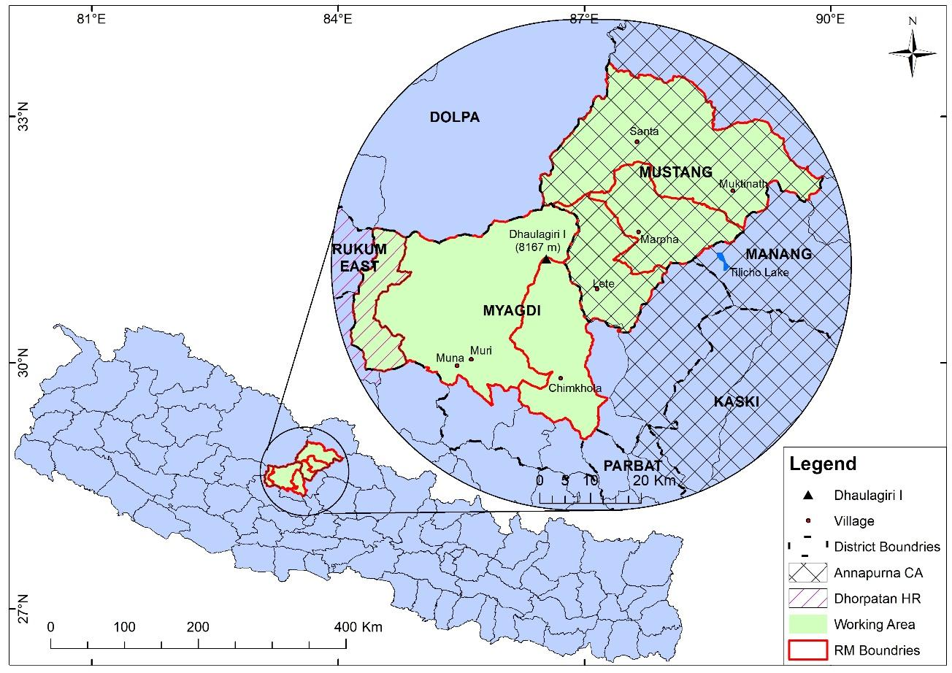 | 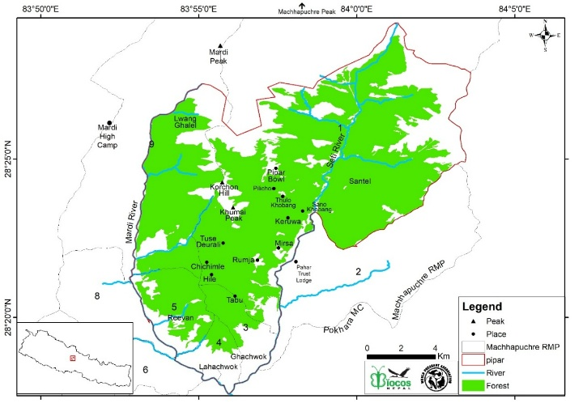
Figure 1: Map showing the Round Dhaulagiri Conservation Program area in Myagdi District | Figure 2: Map showing the Pipar Pheasant Conservation Landscape (PPCL), a key working area where multiple conservation programs were implemented during 2025.
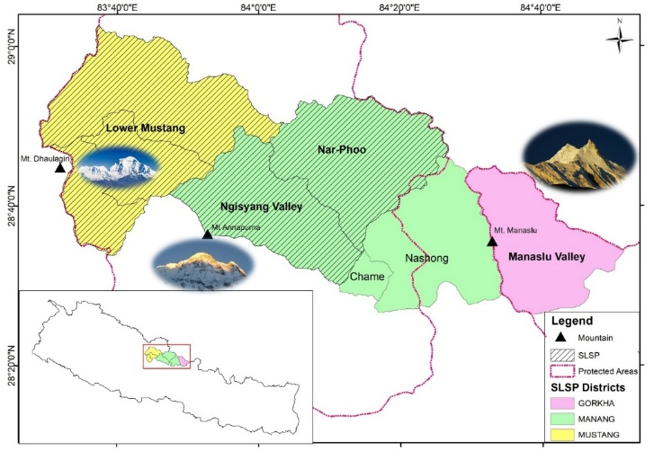
Figure 3:Figure 3 Extended SLSP area: Lower mustang, Neshyang valley and Nar-Phoo valley

CHAPTER 3: ACTIVITIES

3.1. Round Dhaulagiri Conservation Program
In 2025, BIOCOS-Nepal advanced its conservation work across the stunning landscapes surrounding Dhaulagiri Mountain, the world’s seventh-highest peak. The Round Dhaulagiri Conservation Program focused on two iconic species, red pandas in the forests of Myagdi District and snow leopards in the Lower Kali Gandaki Valley of Mustang District, combining fieldwork, community collaboration, and practical conservation actions to protect wildlife while supporting local livelihoods.
For red panda conservation, field teams surveyed forests connected to the Dhorpatan Hunting Reserve and Dhaulagiri Rural Municipality during spring. Across seventeen survey grids, red pandas were confirmed in four core grids at elevations of 3,000–3,600 meters. Teams recorded 30 latrine sites and captured preliminary movement data with 3 camera traps. An estimated 17.29 km² of suitable habitat could support 6–25 red pandas. These findings highlighted key habitat features for red panda survival. In addition to fieldwork, a multi-stakeholder workshop brought together local communities, forest user groups, and government representatives. Participants discussed habitat connectivity, long-term monitoring, and eco-tourism opportunities, strengthening local awareness and promoting collective conservation responsibility.
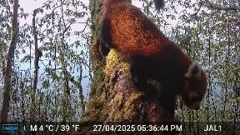 | 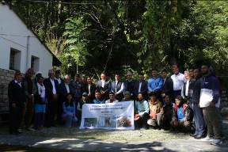
Red panda captured on camera | Participants at the red panda workshop
Snow leopard conservation in the Lower Kali Gandaki Valley, focused on fostering coexistence with herding communities. Patrol teams covered 1,590.5 kilometers throughout the year, monitoring snow leopard movements and their prey. Seventeen camera traps, recorded evidence of snow leopards in key habitats, while prey surveys confirmed 11 wild mammal species. Sixty-six livestock were lost to snow leopards, highlighting ongoing human-wildlife interactions. Despite these predation events, no retaliatory killings were reported in 2025.
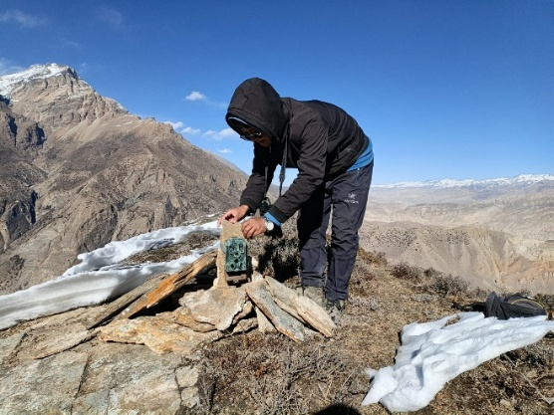 | 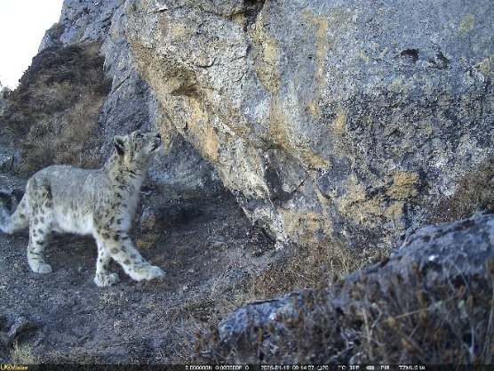
Camera installation on field | Snow leopard from camera trap
To reduce conflict, the Livestock Protection Support Program assisted 75 herders across three rural municipalities. Support included predator-proof corrals, advice on grazing practices, and assistance with government compensation for livestock losses. SMART patrolling and camera-trap monitoring were conducted with local assistants, helping to build long-term capacity and strengthen conservation presence in remote areas.
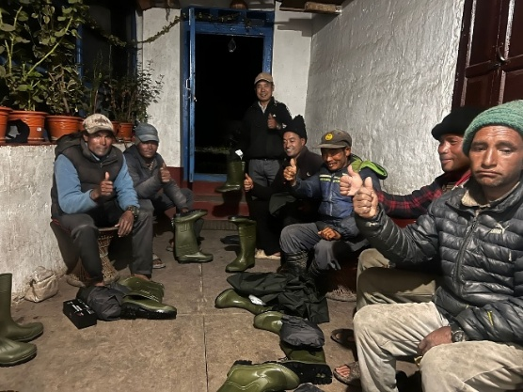 | 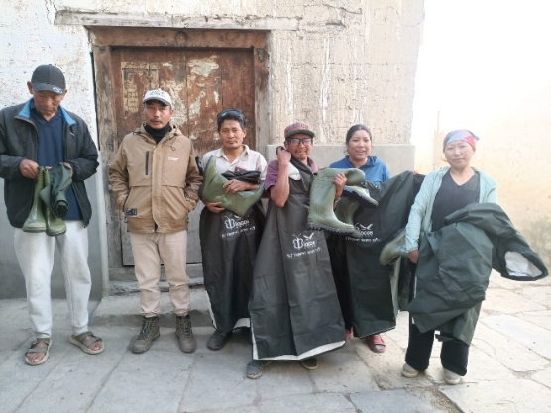
Field gears distribution
By the end of the year, the Round Dhaulagiri Conservation Program had achieved significant milestones. Red pandas were confirmed in core habitats, camera traps provided insights into their movements, and workshops increased local engagement. Snow leopard patrols, prey surveys, and livestock support improved safety for both animals and herders. Together, these efforts contributed to maintaining ecological connectivity, safeguarding globally important species, and supporting sustainable community livelihoods.
In 2025, the program demonstrated that conservation is most effective when it combines wildlife protection with people-centered action. By balancing field research, practical interventions, and community participation, the Round Dhaulagiri Conservation Program ensured that both red pandas and snow leopards continue to thrive in one of Nepal’s most spectacular landscapes.

3.2. Pipar Pheasant Conservation Landscape (PPCL)

3.2.1. Camera Trap Program
BIOCOS-Nepal implemented a Camera Trap Program in the PPCL, situated south of Machhapuchhre Peak inside the Annapurna Conservation Area and aimed to document wildlife presence, understand species diversity, and strengthen evidence-based conservation planning.Camera traps were installed in accessible areas above 2,200 meters, focusing on forest trails, wildlife movement routes, and locations showing signs such as tracks and droppings. Cameras were placed close to the ground (approximately 20–50 cm) to effectively capture images of both mammals and ground-dwelling birds. The camera trap survey recorded a total of 21 wildlife species, including 12 mammal species and 9 bird species. Four species captured by the cameras are listed as Globally Vulnerable on the IUCN Red List: the Himalayan Black Bear, Clouded Leopard, Common Leopard, and Himalayan Serow. In addition, 7 species documented through camera trapping are protected under Schedule-I of Nepal’s National Parks and Wildlife Conservation Act, highlighting the national significance of the PPCL.
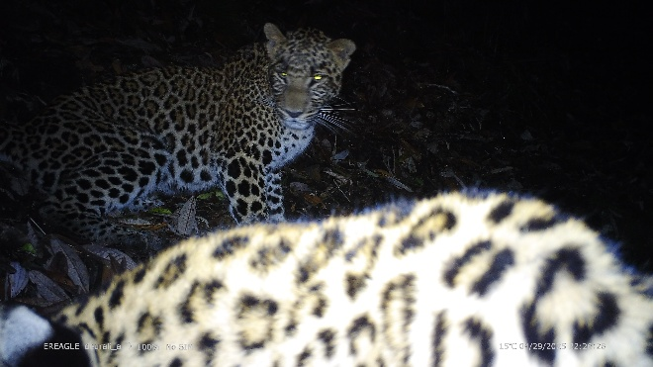 | 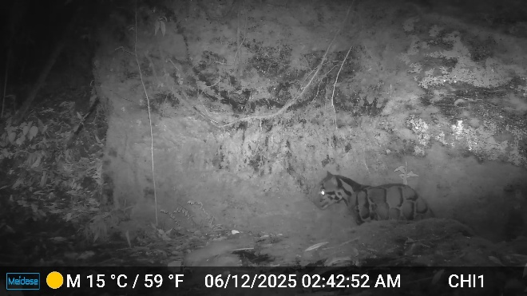
Common Leopard | Clouded Leopard
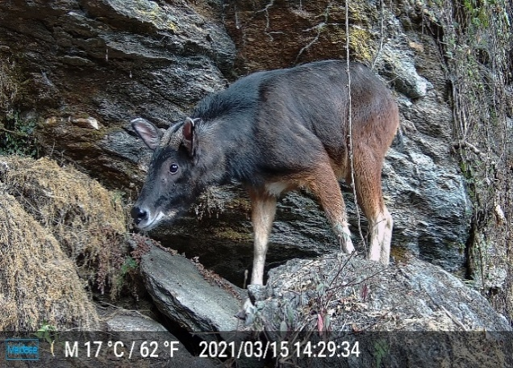 | 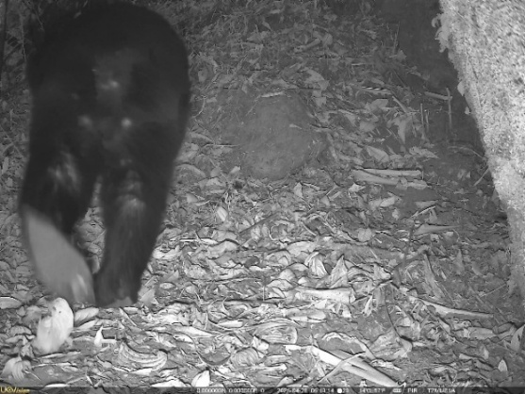
Himalayan Serow | Himalayan Black Beer
The Camera Trap Program within the Pipar Pheasant Conservation Landscape has confirmed the area as a vital refuge for globally threatened and nationally protected species, proving that the Pipar and Khumai forests support a robust, healthy ecosystem far beyond their importance for pheasants alone. By integrating scientific data collection with community outreach, the program utilized field visits and camera monitoring as opportunities to engage herders, trekkers, and residents, successfully boosting local conservation awareness. Ultimately, these efforts have provided essential baseline data and reinforced BIOCOS-Nepal’s commitment to a balanced conservation model that pairs rigorous wildlife monitoring with active local stewardship.

3.2.2. SMART (Spatial Monitoring and Reporting Tool) Monitoring
In 2025, BIOCOS-Nepal strengthened on-ground protection efforts in the Pipar Pheasant Conservation Landscape through the implementation of SMART-based anti-poaching patrols. This program focused on preventing illegal hunting, reducing wildlife threats, and improving monitoring across the Pipar, Khumai, and Korchan forests within the Annapurna Conservation Area.
SMART patrols were conducted regularly by trained local scouts with support from the World Pheasant Association (WPA). Patrol teams moved on foot along forest trails, ridgelines, grazing routes, and known wildlife movement corridors. Between October 2024 and June 2025, patrols covered more than 250 kilometers, ensuring continuous presence in key areas of the landscape.
 | 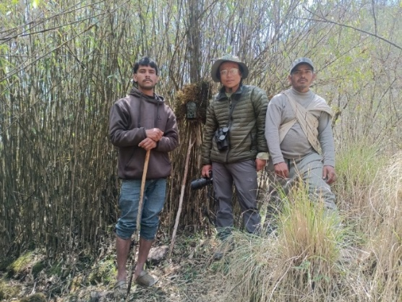
SMART data collection during patrolling | Forest patrolling with local people
A key focus of the SMART program was the detection and removal of snares. During 2025, patrol teams recorded a total of 65 snares, most of which were intended to trap birds. These were primarily detected in Lubruchu, Khumai, and Korchan, with the majority found during the winter months, when forest access is easier and poaching pressure increases. Snares targeting larger mammals, likely musk deer or Himalayan serow, were recorded later in the year during May and June, indicating a seasonal shift in illegal activities.
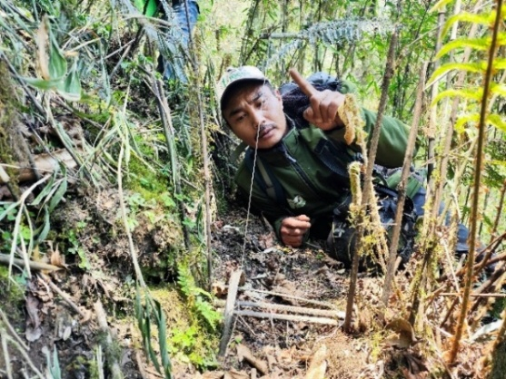 | 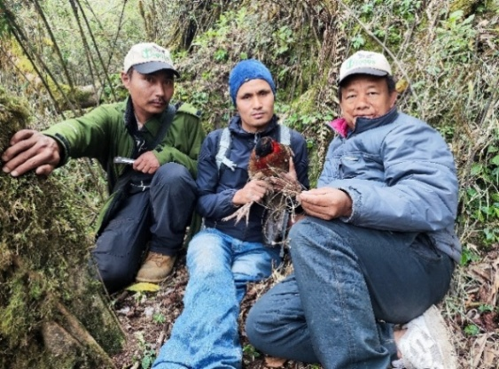
Khutte, leg targeted snare | Munte, neck targeted snare for pheasants
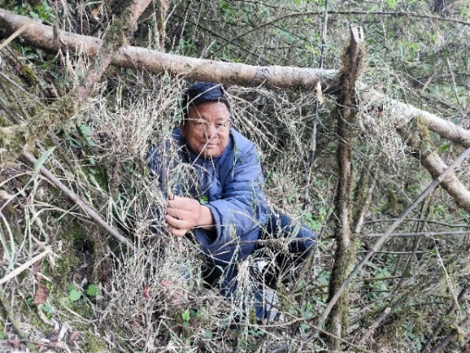 | 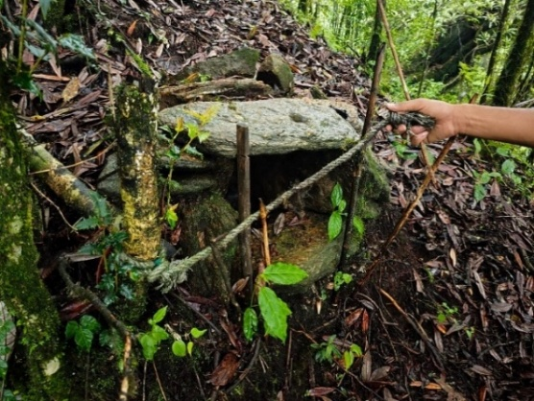
Munte, neck targeted for ungulates | Picture of salt bait snare
SMART patrols also contributed to biodiversity monitoring. Camera traps deployed as part of patrol activities recorded 21 wildlife species including Himalayan Goral, Assamese Macaque, and Satyr Tragopan. These records highlighted the high conservation value of PPCL and reinforced the need for sustained protection. Capacity building was an important part of the SMART program. Local Munal Scout played an active role in patrol activities, including snare removal, camera-trap support, and basic data entry. Engaging local youth in this way helped build local ownership of conservation efforts.
Overall, the SMART-based anti-poaching program in 2025 significantly reduced poaching pressure, improved threat detection, and strengthened wildlife protection across the Pipar Pheasant Conservation Landscape. By combining regular field patrols, simple technology, and local participation, the program contributed to safer habitats for pheasants and other wildlife while building trust with local communities.

3.2.3 Bird Survey
The PPCCL, situated within Annapurna Conservation Area, remains one of the Nepal’s most critical ecological hubs for avian life. In 2025, BIOCOS Nepal conducted survey across the Pipar, Khumai, and Khorchan forests to assess the status of flagship Galliformes and document broader spring bird diversity. The survey continued a monitoring legacy that began in 1979, making PPCL one of the few sites in Nepal where long-term population trends of pheasants can be assessed. The 2025 survey aimed to understand the current status of key pheasant species, expand monitoring to newly included forest areas, and identify emerging threats linked to grazing, tourism, and increasing human movement.
Fieldwork was conducted covering both historically surveyed areas in Pipar and newly incorporated sites in the Khumai and Korchan forests. Surveys were carried out during early morning hours, when pheasants are most vocal and active. Teams followed established forest trails and ridgelines, combining listening-based observations with habitat assessments along the survey routes.
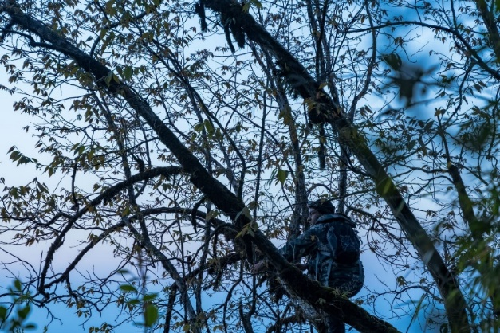 | 
Dawn call survey conducted from a listening point
A total of 205 bird species were recorded during the survey period. This high species richness reflects the ecological diversity of PPCL and confirms its importance as a key bird habitat within the Annapurna Conservation Area. Among the recorded species, 16 were nationally threatened, one species was globally threatened, and 20 species were listed under CITES, highlighting the conservation significance of the area. In addition, 95 biome-restricted species and two restricted-range species were documented.Passerine birds dominated the survey results, accounting for 153 species, which represented approximately 75% of all recorded species.
While this high diversity confirms the landscape's overall health, our monitoring specifically focused on three key indicator species whose populations tell us the most about forest stability:
- Satyr Tragopan: Populations remained stable in the core Pipar forests when compared with records collected over more than four decades. This finding reinforced the long-term conservation value of Pipar as a stronghold for this globally significant species.
- Hill Partridge: Showed a notable increase compared to the 2022 survey, suggesting signs of recovery in some parts of the landscape. Although current numbers have not yet reached historical peaks, the upward trend was encouraging and likely reflects improved habitat conditions and reduced disturbance in certain forest sections.
- Koklass Pheasant: Showed a worrying pattern, no individuals were detected in the historic listening stations of Pipar during the 2025 survey. Only a small number of records were obtained from the Khumai forest sector, indicating a marked long-term decline and raising concerns about the species future in the landscape. Habitat restriction, grazing pressure, and increased human movement were identified as possible contributing factors.
Population estimates suggest that Satyr Tragopan and Hill Partridge maintain moderate numbers across extensive forest habitats. Conversely, the Koklass Pheasant persists at low densities within limited areas, making it highly vulnerable to local extinction without strengthened protection.
Overall, the survey confirms that PPCL continues to support a diverse bird community, including several high-priority species, and provides updated baseline data to guide future monitoring, conservation planning, and awareness efforts while emphasizing the importance of maintaining intact forests and reducing human pressure for long-term biodiversity conservation.

3.2.4. Vegetation and Human Disturbance Assessment
A vegetation and habitat assessment in the PPCL aimed to evaluate the current condition of forests supporting Himalayan pheasants and other wildlife. By revisiting transects first established in 1983, the study offered a rare comparison of present-day forest conditions with records spanning four decades. The survey covered two major forest blocks, Pipar and Khumai, from roughly 1,600 m to 4,000 m in altitude, spanning habitats from lower temperate broadleaved forests to subalpine rhododendron and birch forests. A total of 88 vegetation plots (10 × 10 m) were established—48 in Pipar (24 in the Pipar Bowl and 24 along an altitudinal gradient between 2,200 m and 3,700 m) and 40 in Khumai. Within each plot, data were recorded on plant species presence, abundance, tree height, diameter at breast height, canopy cover, and signs of human use such as grazing, fuelwood collection, and trail disturbance.
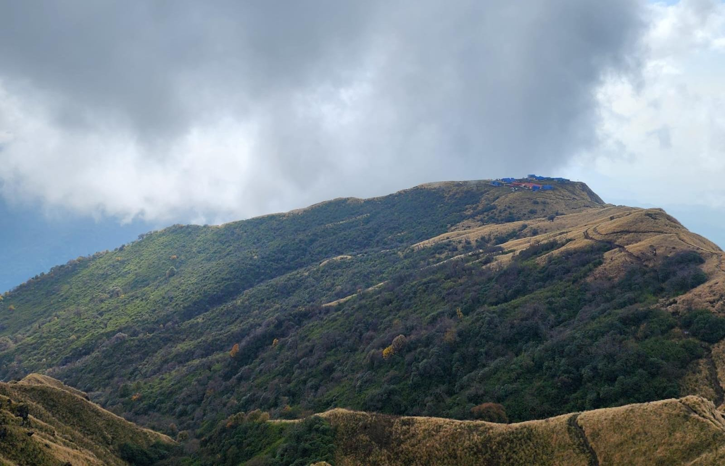 | 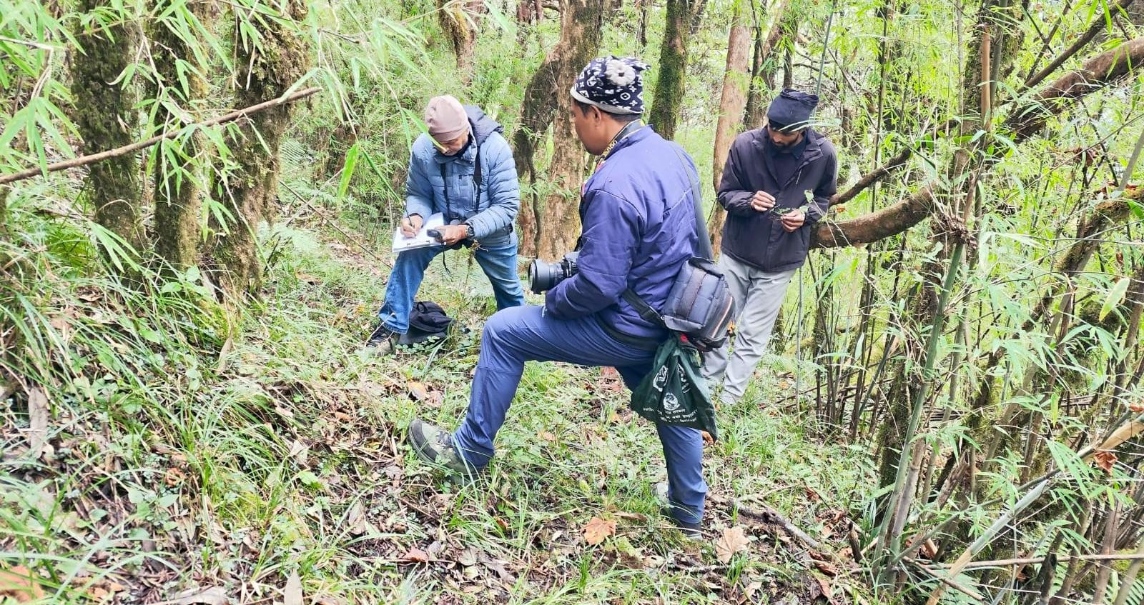
Altitudinal and habitat diversity of the Pipar Pheasant Conservation Landscape. | Estimating the ground coverage.
The survey recorded 256 plant species, of which 250 were identified to species level, representing 185 genera and 83 families. The family Asteraceae was the most species-rich, with 31 species recorded. Viburnum erubescens emerged as the most widespread species, occurring in 8 out of 10 study sites. Among all locations, Pipar Bowl showed the highest plant diversity, with 85 species, highlighting its importance as a core habitat for wildlife.
Based on vegetation composition, altitude, and human use, the landscape was classified into seven major habitat zones, ranging from settlements and cultivated land below 1,700 m to Betula utilis subalpine forest between 3,400 and 3,700 m. These zones closely match the known distribution patterns of key pheasant species such as the Satyr Tragopan, Himalayan Monal, and Koklass Pheasant. Although upper forest areas remain relatively intact, increasing grazing pressure and localized degradation in mid-elevation forests were observed, posing growing risks to ground-dwelling pheasants that rely on dense undergrowth and undisturbed forest floors for breeding and foraging.
Overall, the vegetation assessment confirmed that PPCL continues to support structurally diverse and ecologically important forests. The findings provide essential baseline data for habitat management, pheasant conservation planning, and long-term monitoring, while also highlighting areas where human pressure needs to be managed to ensure the long-term health of the landscape.

3.2.5. Munal Volleyball Cup
The Munal Volleyball Cup was organized as a community engagement and conservation awareness activity to connect local people with biodiversity protection in a simple and relatable way. As volleyball is widely popular in the area, it served as a platform to bring together different age groups and share messages on Himalayan pheasant conservation in an informal setting. Held on 11 October 2025 at Tuse, Machhapuchhre Rural Municipality Ward No. 1, within the Annapurna Conservation Area, the event began with a welcome ceremony and cultural performances by the local Aama Samuha, highlighting the role of women’s groups in supporting community-based conservation efforts.
 | 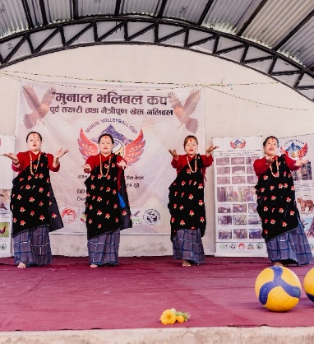
Members of the Aama Samuha Welcoming Guests | Cultural Performance Presented by the Aama Samuha
The tournament brought strong participation from communities around the Pipar Pheasant Conservation Landscape, with six local teams competing under the supervision of three licensed referees. Five matches were played, with the winner receiving NPR 10,000 and the runner-up NPR 5,000. The event attracted a large crowd of residents, youth, students, and community leaders, while conservation messages on pheasant and forest protection were promoted through Munal-themed jerseys, banners, hoarding boards, and informal interactions. Cultural performances and student involvement added to the engagement, showing how sports can serve as a practical platform for conservation awareness and local ownership.
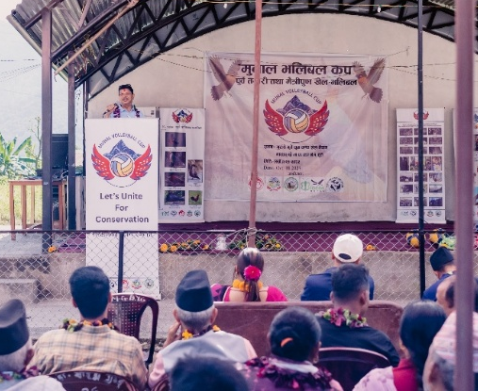 | 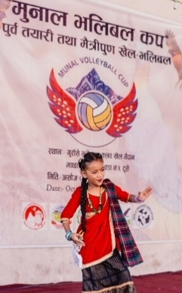
Banners displayed for the Munal Volleyball Cup. | Student performing a cultural dance during the opening ceremony.
The event was organized with the coordination and support of BIOCOS–Nepal, the World Pheasant Association (WPA), the Annapurna Conservation Area Project (ACAP), Green Mountaineering Trekking (GMT), and Machhapuchhre Rural Municipality Ward No. 1, reflecting a collaborative approach that involved local institutions, youth, women’s groups, and community leaders. Overall, the Munal Volleyball Cup demonstrated that sports and cultural activities can serve as practical tools for conservation awareness. By combining volleyball, cultural performances, and community participation, the event strengthened local engagement in wildlife conservation and showed strong potential for similar community-led initiatives in the future within the Pipar Pheasant Conservation Landscape.

3.2.6. Conservation Awareness Programs
WPA and BIOCOS Nepal integrated Junior Conservation Knowledge (JCK), a conservation-focused book by Christine Stone, into the curriculum of 12 local schools through a dedicated teacher training program, providing each school with 10 copies as reference materials. In February 2025, a workshop trained 13 teachers from 11 schools to strengthen biodiversity and pheasant conservation education. To encourage youth engagement, the initiative also included school visits, drawing competitions, and wall art projects, with murals by local artists illustrating native pheasant species as everyday learning tools.
 | 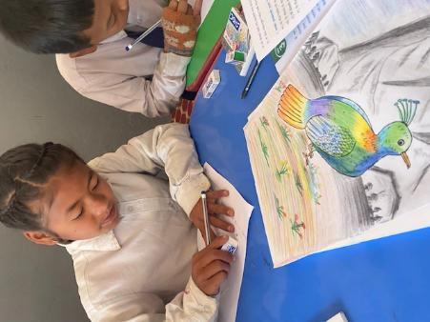
Hand overing JCK to the school management | Student taking part in drawing competition
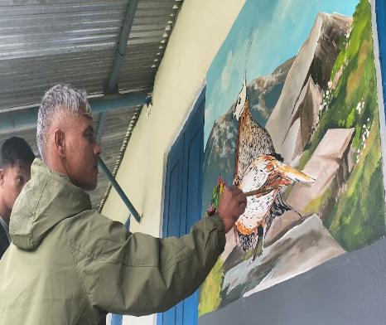 | 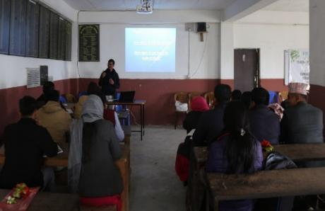
Teacher Painting Pheasant Mural to Inspire Conservation | Teacher Training on Bird identification Techniques

3.3. Snow Leopard Stewardship Program
The Snow Leopard Stewardship Program SLSP began as a pilot initiative in the Neshyang Valley with support from the Great Plains Zoo in 2023 and, by 2025, expanded to include the Lower Mustang Valley and the Nar–Phu Valley. These landscapes are characterized by rugged terrain, harsh climatic conditions, and pastoral livelihoods that depend heavily on livestock. Because livestock depredation is one of the main drivers of conflict with snow leopards, the program placed strong emphasis on field monitoring, community engagement, and practical support to herders.
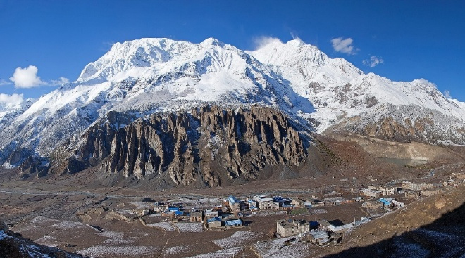
Annapurna Range from Manang village
Between December 2024 and November 2025, rangers and trained local scouts conducted regular patrols across snow leopard habitats, covering 2,781 km and documenting 171 livestock losses caused by snow leopards. Notably, no retaliatory killings occurred during this period, reflecting improved trust and cooperation between communities and conservation teams.
Camera-trap monitoring was central to the program, with 35 cameras deployed in the Neshyang Valley capturing snow leopards at 17 sites. At least seven individuals were identified from 81 independent records, alongside 548 blue sheep (Pseudois nayaur), indicating a healthy prey base. In 2025, the program expanded to 74 cameras across Manang District, adding 39 in the Nar–Phu Valley. Conflict-mitigation measures included a 160-meter protective fence around a yak gathering area, distribution of practical support items for herders, and assistance with government compensation claims, helping reduce livestock losses and strengthen community support for snow leopard conservation.
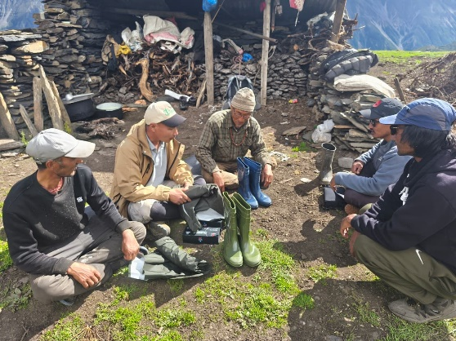 | 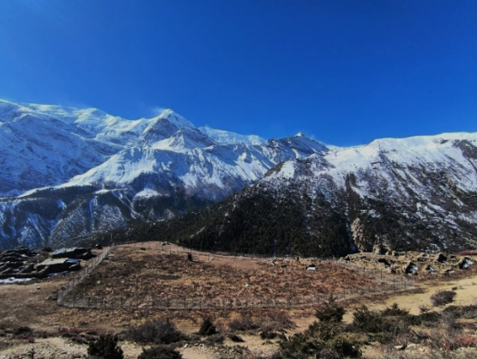
Field gear distribution | Open Enclosure Broad View
Beyond monitoring and conflict mitigation, the program supported nature-based tourism and conservation awareness. BIOCOS-Nepal continued to provide technical assistance to the Snow Leopard Haven (SLH), helping it functions as a center for education and wildlife-based tourism. Camera-trap images and regular monitoring updates increased local interest in snow leopards, encouraging hoteliers and community members to recognize the species as a valuable asset rather than a threat. This contributed to the early development of winter wildlife tourism in the region.
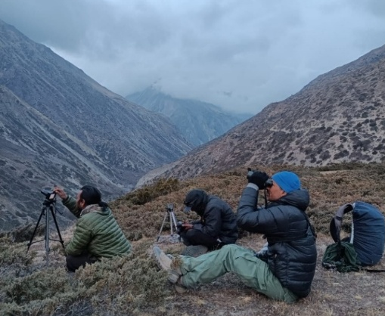 | 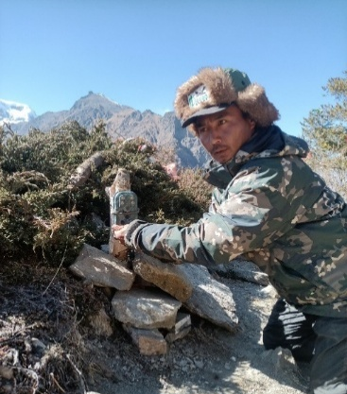
Demonstrating the visitors in the field | Demonstration of camera trap in field
Overall, the Snow Leopard Stewardship Program in 2025 demonstrated that conservation outcomes improve when science-based monitoring is combined with community trust and practical support. By addressing conflict, strengthening local capacity, and promoting stewardship, the program helped create conditions for the long-term survival of snow leopards while supporting the livelihoods of people who share their landscape.

CHAPTER 4: CONCLUSION

4.1. Conclusion
During the reporting period, activities across the Pipar Pheasant Conservation Landscape, the Round Dhaulagiri Conservation Program, and the Snow Leopard Stewardship Program combined research, community engagement, and awareness-based approaches to advance biodiversity conservation. Field-based work, including bird surveys, vegetation assessments, and camera trapping, improved understanding of local habitats and wildlife while reinforcing the importance of long-term monitoring. Community-focused initiatives such as educational programs and sports-based events which engaged youth, women’s groups, community leaders, and local institutions, demonstrating that conservation is most effective when shared and locally supported. By integrating ecological research with social participation, these programs strengthened connections between conservation goals and local communities, providing a solid foundation for sustaining partnerships, field-based research, and community involvement to ensure long-term conservation outcomes and ecosystem resilience.

Annex
Annex 1: Faunal species captured from the PPCL and their IUCN Red list status with their Nepal’s Schedule-I
S. No. | Species | IUCN Red List Status | Protected in Nepal (Schedule-I)
1 | Himalayan Black Bear | Vulnerable | Yes
2 | Clouded Leopard | Vulnerable | Yes
3 | Common Leopard | Vulnerable | Yes
4 | Himalayan Serow | Vulnerable | Yes
5 | Himalayan Goral | Near Threatened | Yes
6 | Assamese Macaque | Near Threatened | Yes
7 | Satyr Tragopan | Near Threatened | Yes
8 | Yellow-billed Magpie | Near Threatened | No
9 | Barking Deer | Least Concern | No
10 | Hill Partridge | Least Concern | No
11 | Yellow-throated Marten | Least Concern | No
12 | Indian Small Mongoose | Least Concern | No
13 | Blue Whistling Thrush | Least Concern | No
14 | Chestnut-crowned Laughingthrush | Least Concern | No
15 | Leopard Cat | Least Concern | No
16 | Alpine Thrush | Least Concern | No
17 | White-browed Rosefinch | Least Concern | No
18 | Grey-winged Blackbird | Least Concern | No
19 | Black-faced Laughingthrush | Least Concern | No
20 | Squirrel (species not specified) | Mostly Least Concern | No

Annex 2: Threatened, Near Threatened and Data Deficient species recorded in the field survey
SN | English Name | Scientific Name | Nepali Name | IUCN Status
 |  |  |  | National | Global
1 | Egyptian Vulture | Neophron percnopterus | सेतो गिद्ध | VU | EN
2 | Bearded Vulture | Gypaetus barbatus | हाडफोर | VU | NT
3 | Himalayan Griffon | Gyps himalayensis | हिमाली गिद्ध | VU | NT
4 | Golden Babbler | Cyanoderma chrysaeum | निगाले वनभ्याकुर | EN | LC
5 | Rusty-fronted Barwing | Actinodura egertoni | कैलोतालु वनचाहर | EN | LC
6 | Satyr Tragopan | Tragopan satyra | मुनाल | VU | LC
7 | Koklass Pheasant | Pucrasia macrolopha | फोक्रास | VU | LC
8 | Barred Cuckoo Dove | Macropygia unchall | धर्के ढुकुर | VU | LC
9 | Golden Eagle | Aquila chrysaetos | सुपर्ण महाचील | VU | LC
10 | Black-headed Shrike-babbler | Pteruthius rufiventer | कालोटाउके भद्राईभ्याकुर | VU | LC
11 | Hume's Bush-warbler | Horornis brunnescens | पीतेदर झाडीफिस्टो | VU | LC
12 | Golden-breasted Fulvetta | Lioparus chrysotis | स्वर्णवक्ष फूलबुट्टा | VU | LC
13 | Great Parrotbill | Paradoxornis aemodium | चाँदे बाँदरचरी | VU | LC
14 | Brown Parrotbill | Paradoxornis unicolor | खैरो बाँदरचरी | VU | LC
15 | Fulvous Parrotbill | Suthora fulvifrons | निगाले बाँदरीचरी | VU | LC
16 | Slender-billed Scimitar-babbler | Pomatorhinus superciliaris | लामोठूँडे पाल्कोटे | VU | LC
17 | Himalayan Monal | Lophophorus impejanus | डाँफे | NT | LC
18 | Bay Woodpecker | Blythipicus pyrrhotis | तामे लाहाँचे | NT | LC
19 | Himalayan Cutia | Cutia nipalensis | कुटिया | NT | LC
20 | Rufous-chinned Laughingthrush | Ianthocincla rufogularis | कैलोकण्ठे तोरीगाँडा | NT | LC
21 | Scaly Laughingthrush | Trochalopteron subunicolor | कत्ले तोरीगाँडा | NT | LC
22 | Large Niltava | Niltava grandis | ठूलो नीलतभा | NT | LC
23 | Scarlet Finch | Carpodacus sipahi | सिपाही तितु | NT | LC
24 | Upland Buzzard | Buteo hemilasius | पहाडी श्येनबाज | DD | LC
EN is Endangered, VU is Vulnerable, NT is Near Threatened, DD is Data Deficient and LC is Least Concern.

Annex 3: CITES Listed bird species
SN | English Name | Scientific Name | Nepali Name | CITES Appendices
1 | Himalayan Monal | Lophophorus impejanus | डाँफे | I
2 | Upland Buzzard | Buteo hemilasius | पहाडी श्येनबाज | II
3 | Blood Pheasant | Ithaginis cruentus | चिलिमे | II
4 | Collared Owlet | Glaucidium brodiei | सानो डुन्डुल | II
5 | Mountain Scops-owl | Otus spilocephalus | लेकाली उलूक | II
6 | Himalayan Owl | Strix nivicolum | कैलो पहाडी उलूक | II
7 | Oriental Honey Buzzard | Pernis ptilorhynchus | मधुहा | II
8 | Himalayan Buzzard | Buteo refectus | श्येनबाज | II
9 | Mountain Hawk-eagle | Nisaetus nipalensis | जुरेचील | II
10 | Black Eagle | Ictinaetus malaiensis | द्रोणक चील | II
11 | Black Kite | Milvus migrans | कालो चील | II
12 | Crested Serpent Eagle | Spilornis cheela | काकाकुल | II
13 | Crested Goshawk | Accipiter trivirgatus | कल्की बसेरा | II
14 | Besra | Accipiter virgatus | बेसरा | II
15 | Red-billed Leiothrix | Leiothrix lutea | रोचिष्णु मिसिया | II
16 | Bearded Vulture | Gypaetus barbatus | हाडफोर | II
17 | Egyptian Vulture | Neophron percnopterus | सेतो गिद्ध | II
18 | Himalayan Griffon | Gyps himalayensis | हिमाली गिद्ध | II
19 | Golden Eagle | Aquila chrysaetos | सुपर्ण महाचील | II
20 | Satyr Tragopan | Tragopan satyra | मुनाल | III

